A

PRACTICAL TRAINING REPORT

ON
Love To Shop
SUBMITTED IN PARTIAL FULFILLMENT OF THE REQUIREMENT FOR

COMPLETION OF DEGREE

MASTER OF COMPUTER APPLICATION

BY
Name
Roll No-

SUBMITTED TO

A.B.C. COLLEGE OF ENGINEERING AND TECHNOLOGY
Noida-1111111(U.P.)

Acknowledgement

Keep away from people who try to belittle your ambitions. Small people always do that, but the really great make you feel that you too, can become great.

I take this opportunity to express my sincere thanks and deep gratitude to all those people who extended their wholehearted co-operation and have helped me in completing this project successfully.

First of all, I would like to thank Mr. Nitin, Director (GNIX Infosoft) for creating opportunities to undertake me in the esteemed organization.
Special thanks to Mr. Shikhar Kumar Project Manager for all the help and guidance extended to me by him in every stage during my training. His inspiring suggestions and timely guidance enabled me to perceive the various aspects of the project in a new light.
I am highly indebted and graceful to Mr. Prabhat kumar(Project Leader) and Mr.Hasan (Team Leader) for Their strict supervision, constant encouragement, inspiration and guidance, which ensure the worthiness of my work. Working under them was an enrich experience. I express my sincere thanks to my senior of software development department for their encouragement and valuable suggestion
I would also thank to my Mr.------, HOD (MCA Dept.) & my internal project guide Mr. ------- who guided me a lot in completing this project.I would also like to thank my parents & project mate for guiding and encouraging me throughout the duration of the project.
In all I found a congenial work environment in GNIXInfosoft and this completion of the project will mark a new beginning for me in the coming days.

Name
MCA -^{th} Sem
Roll No. :

DECLARATION

I, Name--, hereby declare that the report of the project entitled “emart” has not presented as a part of any other academic work to get my degree or certificate except College name for the fulfillment of the requirements for the degree of Master of Computer Application.

Name

CERTIFICATE OF ORIGINALITY

This is to certify that the project entitled emart being submitted for the partial fulfillment of degree of MCA, session 2005-2006, is a record of work carried out by Name under my guidance and supervision.

This is to further certify that the student has attended the GNIX Infosoft, NOIDA for the 6 months after the fifth semester theory exams. His work has been satisfactory and commendable.

I wish him success in his life.

Date:

Place:

CERTIFICATE

This is to certify that Name, a bonefide student of MCA of batch 2003-2006 has completed the Project titled “emart” being submitted for the partial fulfillment of degree of MCA.

This is to further certify that the student has attended the College name . and GNIX Infosoft, NOIDA for the 6 months after the fifth semester theory exams. His work has been satisfactory and commendable.

Date:
Mr. -----------
HOD MCA Department
Place: College name

CONTENTS

S.N. Title

- Introduction

Company Profile

- Project Detail

Introduction
Project description
Objective

- System Development methodologies

- Initial Investigation and

System Requirements

System Study and Problem Formulation
Project Category
Plateform(Technologies/Tools)
Front-end and Back-end Tools
Software and Hardware Used

- Feasibility Study

- System Design

Data Flow Diagrams
E-R Diagrams
Flow Chart
Data Base Design

- Module Description

- EMART Architecture

- Web Pages(Input/Output Screens)

- Testing and System Security

- Quality Assurance

- Implementation and maintenance

- Evaluation

- Conclusion

- Bibliography

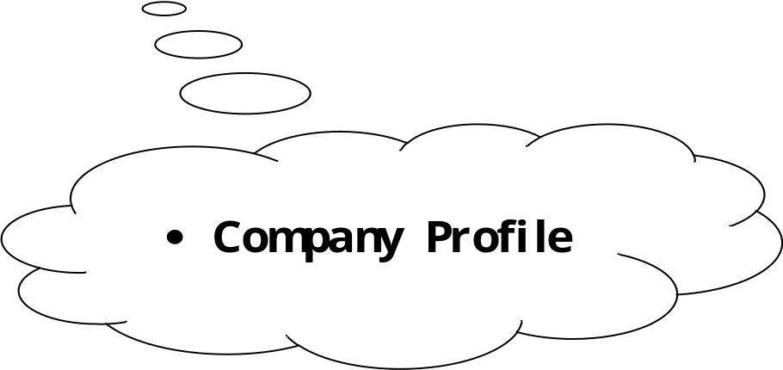

COMPANY PROFILE

GNIX Infosoft A QUALITY SOLUTION COMPANY

This is the era of Information Technology. Its significance is vital in our lives because it presents infinite opportunities for growth and development, all this through Internet. A key ingredient for the Internet to be successful is the state-of-art net infrastructure to converge different media and sources with integral knowledge and clear concept are very essential. This has been the main motivation for our launching GNIX InfoSoft as an intensive unit of Training and Development centre.

GNIX InfoSoft is a leading company in providing quality solutions in the IT industry. It is information, training and complete solution providing company bringing high quality services to the clientele. It is proud to have a satisfied clientele of leading corporate business houses. We are professionally managed company with a vision and mission to provide completes IT solutions to the entrepreneurs. A harmonious combination of man and machine, in which man gets precedence over the machine.

Information is the hallmark of today's world. A drive for productivity and the ability to offer quality solutions on information superhighway are the key to development. Gnix Infosoft India (Pvt.) Ltd. (hereby mentioned as CBK as well as company) has mirrored that drive and ability.

The essence of true development since 1998 which by enhancing growth with the presence of social justice, promoting and cherishing the growth of those associated with the clients who are the true partners in progress.

There is no shortcut to success so as in the case of IT industry too. It is never possible without innovation, an eye for vision, a strong will to succeed and unlimited quality service. Quality objectives, precise and time bound, are the root criteria for success and development and it is not an exception with Gnix.

Gnix Infosoft will leave no stone unturned to take its customer to the topmost rung of ladder of success. A result that is translated at Gnix i.e. - in tune with technology with time and trust, truth and tradition, and requirement is the principle assets of Gnix. Gnix has two divisions working at the moment - Training division as Compu Home and a software development division. It is the development division that is offering this project training as detailed in this document.

GNIX InfoSoft Development Centre

GNIX InfoSoft aims at providing complete and Quality Solution to its clients in all spheres of IT activities. Strategic tie-ups with IBM, Compaq, Hewlett-Packard, SUN Microsystems, HCL, Acer, MICROSOFT, Computer Associates, Cisco, 3Com, Nortal Networks, AMP, Mod-Tap and AT&T with a team of highly qualified professionals are the strong points of the organization. Quality being the hallmark of the organization, GNIX InfoSoft provides tailored solution and takes on turnkey projects. Gnix Infosoft also provides Consultancy services for all IT related matters to its clients. With the revolving strategy and re-structuring, Gnix Infosoft has now started offering Web based solutions and gearing towards providing the E-Commerce / M-Commerce solutions to its existing and new clients

1.1 OUR VISION

We shall define ourselves in the cutting edge technology in the coming era. We shall create honest working environment with see-through-glass planning.

1.2 OUR MISSION

To create opportunity for growth & self actualization to trainees and provide an environment of highly conducive works culture.

Work related areas @ Gnix Infosoft:

- Web Page designing and hosting
- Internet and Intranet Solutions
- Web based applications development
- Client / Server Applications Development
- Re-engineering
- Research & Development in WAP and Web related conversing technologies
- Corporate training
- High-end User Training (Vocational)

PARTIAL LIST OF OUR ESTEEMED CLIENTS

- NOKIA INDIA (P) LTD.
- COSMIC INFOTECH SOLUTIONS (CITeS)
- HONKONG AND SHANGHAI BANKING CORPORATION (HDFC)
- EXL SERVICE.COM
- NET2.TRAVELS.COM
- CELMANIA.COM
- POLAROID INDIA LTD.
- PERFETTI INDIA LTD.
- GLOBAL NETCOM SERVICES PVT. LTD.
- EBONY
- AVON BEAUTY PRODUCTS INDIA PVT. LTD.
- ADEPTIA INDIA PVT. LTD.
- CALTEXT LUBRICANTS INDIA PVT. LTD.
- COSMO FERRITES LTD.
- TRISOFT DESIGN
- SHRIRAM AUTOMOTIVE PRODUCTS LTD.
- NIKSUN INDIA PVT. LTD.
- ISPAT INDUSTRIES LTD.
- OSWAL CHEMICALS & FERTILIZERS LTD.
- MINISTRY OF TEXTILES
- MINISTRY OF ENVIRONMENT
- S.R.C.C.
- SAIL
- MODI ENTERTAINMENT NETWORK
- RAJYASABHA
- APTECH COMPUTER EDUCATION LTD.
- ZEE INTERACTIVE LEARNING SYSTEMS LTD.
- EL-ZEE TELEVISION LTD.
- SAHARA INDIA PARIVAR.
- DCM INDUSTRIES LTD.
- JALDI.COM
- NOBLE & HEWITT
- BEETAL FINANCIAL SERVICES LTD.
- TRICON RESTAURANTS INTERNATIONALS.
- REEBOK INDIA COMPANY
- D.R.D.O.
- AUTOMAX LTD.
- MMTC LIMITED
- BANK OF NOVA SCOTIA.
- HDM INDIA LTD.
- ELOFIC INDUSTRIES LTD.
- NIKSUN INDIA PVT. LTD.
- REDIFFUSION DY & R BRAND COMMUNICATIONS.
- SATYA SONS
- ARMY GOLF COURSE
- HUNTER DOUGLAS
- MILITARY HOSPITAL
- COSMIC INFOTECH SOLUTIONS
- BIRLA TECHNICAL SERVICES
- SPECTRUM MAGAZIES LTD.
- INDOMAG STEELS
- JAMIA MILIA ISLAMIC UNIVERSITY
- MODICARE
- HOLIDAY INN MUMBAI
- HILTI INDIA
- RAJDOOT PAINTS
- HYDERABAD INDUSTRIES
- AVL SOFTWARE (P) LTD.
- JAIPRAKASH INDUSTRIES LTD.
- CRM DIVISION OF TISCO

SOME OF THE WEB PROJECTS UNDERTAKEN

Company URL

AZ DATAMALL www.dwebonline.com
MA ASSOCIATES www.ma-associates.com
DP ASSOCIATES www.dp-associates.org
POLARIS www.bankwareindia.com
CHEVRON www.chevronhotels.com
SRF Ltd. www.srf-limited.com
RK BERI www.rkberiandsons.com
FINEDGE www.finedgetech.com
CREMICA FOODS LTD. www.Cremicafoods.com
RAMA PAPERS www.ramapapers.com
MICRO DATA PRODUCTS LTD. www.microdataproducts.com
CENTRE POINT HOTEL www.centerpointhotel.com
GULMOHUR SCHOOL www.gulmohurschool.com
VASANT VIHAR CHURCH www.stdominicchurch.org
YOUNG ADVERTISE www.youngadds.com
JSOFT www.onlineexam.com
KIRAN SOCIETY www.matritva.com

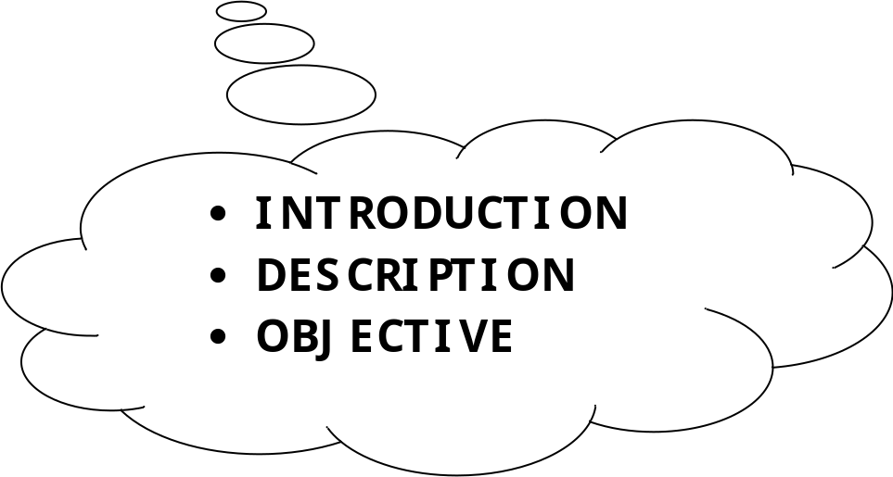

INTRODUCTION

PROJECT DETAIL

INTRODUCTION
The emart is the part of the sample application that provides customers with online shopping. Through a Web browser, a customer can browse the catalog, place items to purchase into a virtual shopping cart, create and sign in to a user account, and purchase the shopping cart contents by placing an order with a credit card.
By integrating information and improving processes, emart will help improve enterprise-wide decision support and operational efficiency. Improved efficiency translates into:
- More resources to support the enterprise .
- Improved customer service
- Web-based and more user friendly interfaces to buyers .
An extremely powerful marketing tool, emart’s ability to suggestively sell alternate and complementary products; e.g. if a customer selects the "standard" version of a product, you can recommend that they also consider the "pro" version or if your customer chooses a pair of pants, you can suggest that they also consider a belt and socks. Simply specify related product skus and optional text in a product’s definition in your Merchant Administrator, and PDG Shopping Cart will up-sell or recommend related products to your customers automatically

PROJECT DESCRIPTION

DESCRIPTION OF PROJECT

The category screen shows all of the products available for a particular category.

The product screen shows all of the items in a particular product. Product screen’s right column of the list shows the price of the item, and includes a link labelled Add to Cart. This link, which also appears on screen for the corresponding item, allows the customer to add the item to the cart without looking at the item details

The item screen shows detailed information about an individual item for sale .
The Add to Cart link, when clicked, adds an order for the item to the shopping cart, and then shows the shopping cart contents

The cart screen lists the items currently in the cart, allows the customer to change the quantity of each item ordered, and shows a title. It also includes a link to remove the item from the cart, and a link Proceed to Checkout which, when clicked, shows the order information screen if the user is signed on. If the user is not signed on, the signon screen is shown instead.
The signon screen allows an existing customer to sign in as an existing user, and a new customer to create an account. An existing customer enters a user name and password, and the application displays the Order Information screen shown in . A new customer enters a user name and password and clicks the button Create New Account. The application creates a user with the requested password. If user creation succeeds, the application displays the Account Information screen.
The account information screen, shown in collects information about a new customer, including contact information, a credit card, and personal preferences. This is also the screen displayed whenever the customer clicks the Account link at the top right corner of the screen (beneath the Search box). Clicking the Update button directs the browser to a page that summarizes the information entered.
The Order Information screen allows the user to enter billing and shipping address. Default values for the addresses come from the contact information for the currently signed-in customer. This information is transmitted to the application when the user clicks Submit. The application creates a new order, sends it to the order processing center, and displays the Order Complete screen.
The Order Complete screen verifies to the user that the order has been placed. The screen includes the order number

Key Strengths
A steady stream of innovative features born of a
deep understanding of online shopping as a social
experience. Recent enhancements and additions
include:

g The beginnings of social networking
capabilities, with customers able to connect
with and keep tabs on a network of friends

g The ability for users to “tag” products by
assigning them keywords

g Personal blogs for customers

g Product discussion boards

g The ability to upload images as visual reviews
and product commentary

OBJECTIVE

OBJECTIVES
Our Objective
Our objective was to look at online retail from a customer’s point-of-view and determine which
of the biggest US-based ecommerce sites was providing the best customer experience.
A secondary aim was to zero in on key trends and identify opportunities for high-impact
customer experience improvements.

Our Approach

We examined the entire experience. Unlike some studies that focus only on browsing,
we looked at the entire experience from the first moment on the site through selection,
purchase, shipping and returns.

We combined objective measurement with expert subjective analysis. Metrics
have a strong appeal, but in something that involves as many intangibles as the customer
experience measurement can only take you so far. With this in mind, we split our analysis
between straightforward objective grading and the expert opinions of our panelists. (In
poker terms, think of a good objective score as a table stakes and a good subjective
score as a hand that could win you the game.)

We analyzed a large pool of sites defined by a third party.

Objective evaluation criterion
the interface must use language that is easily understood by target users .

the interface must use graphics or icons that are easily understood by target
users .

the text must be easy to read .

navigation elements must be easily recognized and understood .

product categories must be well thought out, and intuitive .

there must be effective decision support tools to guide you through the exploration
process .

the product must be clearly displayed with appropriate visualization tools .

If customer I have been to the site before, it must remember me and personalize customer’s
subsequent experience?

it is easy to keep track of things customer want to buy .

customer need to register in order to make a purchase or access certain
content .

it does have a history of customer’s transactions that he can easily access .

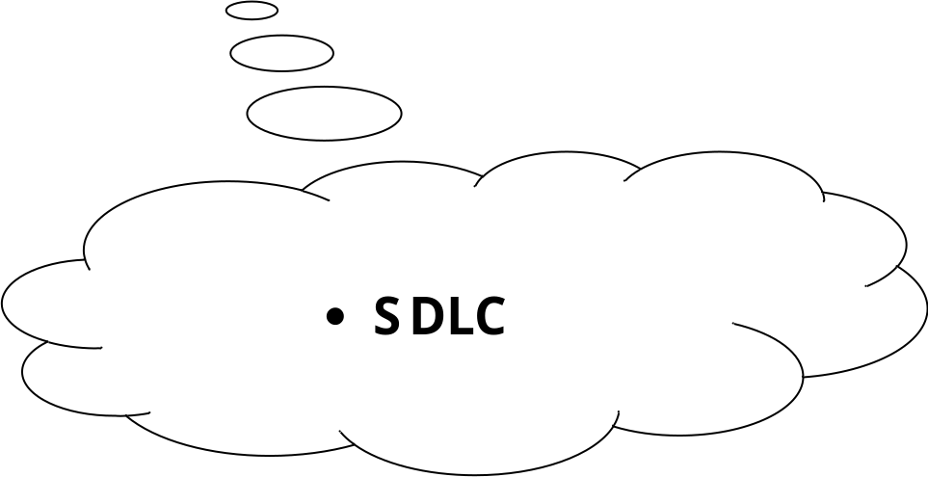

SYSTEM DEVELOPMENT
LIFE CYCLE

System Development Methodology

System Development Life Cycle

PHASES:

1.2.1 Initiation Phase
The initiation of a system (or project) begins when a business need or opportunity is identified. A Project Manager should be appointed to manage the project. This business need is documented in a Concept Proposal. After the Concept Proposal is approved, the System Concept Development Phase begins.

1.2.2 System Concept Development Phase
Once a business need is approved, the approaches for accomplishing the concept are reviewed for feasibility and appropriateness. The Systems Boundary Document identifies the scope of the system and requires Senior Official approval and funding before beginning the Planning Phase.

1.2.3 Planning Phase
The concept is further developed to describe how the business will operate once the approved system is implemented, and to assess how the system will impact employee and customer privacy. To ensure the products and /or services provide the required capability on-time and within budget, project resources, activities, schedules, tools, and reviews are defined. Additionally, security certification and accreditation activities begin with the identification of system security requirements and the completion of a high level vulnerability assessment.

1.2.4 Requirements Analysis Phase
Functional user requirements are formally defined and delineate the requirements in terms of data, system performance, security, and maintainability requirements for the system. All requirements are defined to a level of detail sufficient for systems design to proceed. All requirements need to be measurable and testable and relate to the business need or opportunity identified in the Initiation Phase.

1.2.5 Design Phase
The physical characteristics of the system are designed during this phase. The operating environment is established, major subsystems and their inputs and outputs are defined, and processes are allocated to resources. Everything requiring user input or approval must be documented and reviewed by the user. The physical characteristics of the system are specified and a detailed design is prepared. Subsystems identified during design are used to create a detailed structure of the system. Each subsystem is partitioned into one or more design units or modules. Detailed logic specifications are prepared for each software module.

1.2.6 Development Phase
The detailed specifications produced during the design phase are translated into hardware, communications, and executable software. Software shall be unit tested, integrated, and retested in a systematic manner. Hardware is assembled and tested.

1.2.7 Integration and Test Phase
The various components of the system are integrated and systematically tested. The user tests the system to ensure that the functional requirements, as defined in the functional requirements document, are satisfied by the developed or modified system. Prior to installing and operating the system in a production environment, the system must undergo certification and accreditation activities.

1.2.8 Implementation Phase
The system or system modifications are installed and made operational in a production environment. The phase is initiated after the system has been tested and accepted by the user. This phase continues until the system is operating in production in accordance with the defined user requirements.

1.2.9 Operations and Maintenance Phase
The system operation is ongoing. The system is monitored for continued performance in accordance with user requirements, and needed system modifications are incorporated. The operational system is periodically assessed through In-Process Reviews to determine how the system can be made more efficient and effective. Operations continue as long as the system can be effectively adapted to respond to an organization’s needs. When modifications or changes are identified as necessary, the system may reenter the planning phase.

1.2.10 Disposition Phase
The disposition activities ensure the orderly termination of the system and preserve the vital information about the system so that some or all of the information may be reactivated in the future if necessary. Particular emphasis is given to proper preservation of the data processed by the system, so that the data is effectively migrated to another system or archived in accordance with applicable records management regulations and policies, for potential future access.

SDLC Objectives
This guide was developed to disseminate proven practices to system developers, project managers, program/account analysts and system owners/users throughout the DOJ. The specific objectives expected include the following:
- To reduce the risk of project failure
- To consider system and data requirements throughout the entire life of the system
- To identify technical and management issues early
- To disclose all life cycle costs to guide business decisions
- To foster realistic expectations of what the systems will and will not provide
- To provide information to better balance programmatic, technical, management, and cost aspects of proposed system development or modification
- To encourage periodic evaluations to identify systems that are no longer effective
- To measure progress and status for effective corrective action
- To support effective resource management and budget planning
- To consider meeting current and future business requirements
Key Principles
This guidance document refines traditional information system life cycle management approaches to reflect the principles outlined in the following subsections. These are the foundations for life cycle management.
Life Cycle Management Should be used to Ensure a Structured Approach to Information Systems Development, Maintenance, and Operation
This SDLC describes an overall structured approach to information management. Primary emphasis is placed on the information and systems decisions to be made and the proper timing of decisions. The manual provides a flexible framework for approaching a variety of systems projects. The framework enables system developers, project managers, program/account analysts, and system owners/users to combine activities, processes, and products, as appropriate, and to select the tools and methodologies best suited to the unique needs of each project.
Support the use of an Integrated Product Team
The establishment of an Integrated Product Team (IPT) can aid in the success of a project. An IPT is a multidisciplinary group of people who support the Project Manager in the planning, execution, delivery and implementation of life cycle decisions for the project. The IPT is composed of qualified empowered individuals from all appropriate functional disciplines that have a stake in the success of the project. Working together in a proactive, open communication, team oriented environment can aid in building a successful project and providing decision makers with the necessary information to make the right decisions at the right time.
Each System Project must have a Program Sponsor
To help ensure effective planning, management, and commitment to information systems, each project must have a clearly identified program sponsor. The program sponsor serves in a leadership role, providing guidance to the project team and securing, from senior management, the required reviews and approvals at specific points in the life cycle. An approval from senior management is required after the completion of the first seven of the SDLC phases, annually during Operations and Maintenance Phase and six-months after the Disposition Phase. Senior management approval authority may be varied based on dollar value, visibility level, congressional interests or a combination of these.
The program sponsor is responsible for identifying who will be responsible for formally accepting the delivered system at the end of the Implementation Phase.
A Single Project Manager must be Selected for Each System Project
The Project Manager has responsibility for the success of the project and works through a project team and other supporting organization structures, such as working groups or user groups, to accomplish the objectives of the project. Regardless of organizational affiliation, the Project Manager is accountable and responsible for ensuring that project activities and decisions consider the needs of all organizations that will be affected by the system. The Project Manager develops a project charter to define and clearly identify the lines of authority between and within the agency’s executive management, program sponsor, (user/customer), and developer for purposes of management and oversight.
A Comprehensive Project Management Plan is Required for Each System Project
The project management plan is a pivotal element in the successful solution of an information management requirement. The project management plan must describe how each life cycle phase will be accomplished to suit the specific characteristics of the project. The project management plan is a vehicle for documenting the project scope, tasks, schedule, allocated resources, and interrelationships with other projects. The plan is used to provide direction to the many activities of the life cycle and must be refined and expanded throughout the life cycle.

Specific Individuals Must be Assigned to Perform Key Roles Throughout the Life Cycle
Certain roles are considered vital to a successful system project and at least one individual must be designated as responsible for each key role. Assignments may be made on a full- or part-time basis as appropriate. Key roles include program/functional management, quality assurance, security, telecommunications management, data administration, database administration, logistics, financial, systems engineering, test and evaluation, contracts management, and configuration management. For most projects, more than one individual should represent the actual or potential users of the system (that is, program staff) and should be designated by the Program Manager of the program and organization

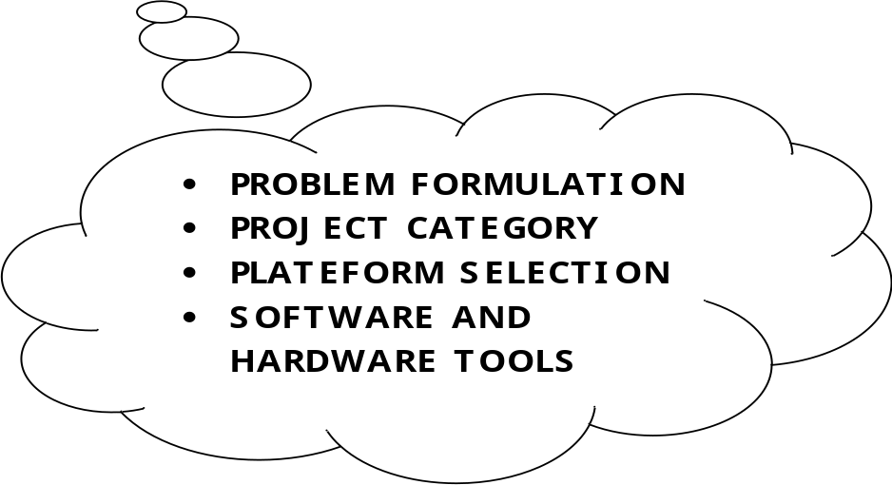

SYSTEM STUDY AND PROBLEM FORMULATION

REQUIRMENTS ANALYSYS

SYSTEM STUDY AND PROBLEM FORMULATION

THE EXISTING SYSTEM

The existing system work manually. The existing system has got lot of intricacies within itself and need lot of human effort and paper works. All above the data need to be maintained on ledgers and maintaining this is a tedious and risky process. As the transactions increases, so the data too. So the task of maintaining them increases exponentially. To view a data may need lot of paper to be searched.

Some of the negative aspects of the existing system are as follows:
- Course of action is time consuming. Wherever a need for search arises, the process evolves search through paper records.
- Readability of records is constrained. All the records may not be handled or written by the same person. So the format and style of records differ and hence it is difficult to understand.
- Paper records are easily damaged in course of time. The life time of paper record is unreliable less that it easily gets spoiled.
- Expenditure is high. Manual system needs added man power.
- Prone to corruption by unauthorized users. Securing of manual system is not fully guaranteed. Inaccuracy can be expected. Data can get easily scratched.
- Techniques used are more complicated. Proper techniques are not exposed, so the functioning is intricate.

To overcome these, the proposed system has been suggested.

THE PROPOSED SYSTEM

The proposed system is a computerized one. This has greater accuracy and efficiency. This takes only limited time for calculation.
The proposed system can be used to maintain efficiently the HR Department schedule of any type of company. In larger organizations employees are large. At that time also the proposed system is useful and helpful. HR Management System is not only become a desire of the company but it become the need of the company.

The system includes two users.
- Administrator(HR)
- General User
The user gets into the system using user name and a unique password. Each user has his own accessibility permission to accomplish his task flawlessly.

Advantages of the proposed system are
- Easy access to the data
- The new system is more user friendly, reliable and flexible.
- Pop-up menus to carry out transactions for a new user, and for other alert messages.
- Timely Report generation.

Requirement Analysis
At the heart of system analysis is a detailed understanding of all important facets of business area under investigation. (For this reason, the process of acquiring this is often termed the detailed investigation) Analyst, wirking closely with the employees and managers, must study the business process to answer
these key questions:

- What is being done?
- How is it being done?
- How frequent does it occur?
- How great is the volume of transaction or decisions?
- How well is the task being performed?
- Does a problem exist?
- If a problem exist, how serious is it?
- If a problem exists, what is the underlying cause?

Requirement analysis relies on fact-finding techniques. These include:

- Interview
- Questionnaires
- Record inspection
- On-site observation

IDENTIFICATION OF NEED

In the world we are growing for globalization day by day with the development in IT resources and advancement, by using latest technologies every organization wants to beat its competitors and want to grow. Enterprise Resourceful Planning is the need of today’s organization. Survival on manual system is difficult so, that’s why organization of the corporate world wants to computerize their departments. The modules should be complete database driven and interactive that should provide the proper information about the Placement and Training Organization.

Success of any system depends up to a large extent on how accurately a problem is defined, thoroughly investigated and properly carried out to the choice of solution. Analysis is the only phase in which the requirements for the new system are identified. System analysis is a detailed study of the various operations performed by a system and their relationship within and outside of the system. The question is: what must be done to solve the problem? One aspect of analysis is defining the boundaries of the system and determining whether or not a candidate system should consider other related system. During analysis data are collected on the available files, decision points and transactions handled by the parent system. Data flow diagram, interviews, onsite observations, questionnaires are used as a logical system model and tools to perform the analysis.

An analyst is responsible for performing following tasks:

- Gathered all facts about the present system from the employees.

- Studied strength and weakness of the current system.

- Determined “what” must be done to solve the problem.

- Prepared a functional specifications document.

In order to reduce the time, there is a need for computerized system that cans retrieve data, insert data, update existing data or delete existing data. These modules are developed wit the aim of reducing time, reducing manpower, reducing cost so that the records can be easily maintained. The volume of work and complexity are increasing year by year. This system reduces complexity and workload.

PRELIMINARY INVESTIGATION

A request to take assistance from information system can be made for many reasons, but in each case some one in the organization initiate the request. When the request is made, the first system activity the preliminary investigation begins. This activity has three parts:
- Request clarification
- Feasible Study
- Request approval

Many requests from employees and users in the organization are not clearly defined. Therefore, it becomes necessary that project request must be examined and clarified properly before considering systems investigation.

The feasibility study is carried out by a small group of people who are familiar with information system techniques, understand the parts of the business or organization that will be involved or affected by the project, and are skilled in the system analysis and design process.
- Request Approval:

It is not necessary that all request projects are desirable or feasible. Some organizations receive so many projects request from employees that only a few of them can be purchased. However, those projects that are feasible and desirable should be put into a schedule.
In some cases, development can start immediately, although usually system staff members are busy on other ongoing projects. When such situation arises, management decides which projects are more urgent and schedule them accordingly. After a project request is approved, its cost, priority, completion time and personal requirements are estimated and used to determine where to add it to any existing project list. Later on, when the other projects have been completed, the proposed application development can be initiated.
Analysis is a process of studying a problem and to find the best solution to that problem. System analysis gives us the target for the design and the implementation. Analysis is one phase, which is important phase for system development lie cycle. System development is a problem solving techniques. Analysis involves interviewing the client and the user. Three people and the existing documents about the current mode of operation are the basic source of information for the analyst.

Analysis is the process of studying a problem to find the best solution to that problem. System analysis gives us the target for the design and the implementation. Analysis is one phase of the very important phase of the system development life cycle. System development is a problem solving techniques. Analyses involve interviewing the client and the user. These people and the existing document about the current mode of operation are the basic source of information for the analyst.
Human Resource Department of the organization controls the manpower planning by recording manpower requirements, grade, job specifications and presently vacancies and strength. It maintains the candidate’s databank for the respective post.

SOFTWARE ENGINEERING PARADIGM

Computer Aided Software Engineering can be as simple as a single tool that support a specific software engineering activity or as complex as a complete “environment “ that encompasses tools, a database, people, hardware, a network, operating system, standards, and myriad other components. Each building block forms a foundation for the next, with tools sitting as the top of the heap. It is interesting to note that the foundation for effective CASE environment has relatively little to do for software engineering tools themselves. Rather, successful environments appropriate hardware and systems software. In addition, the environment architecture must consider the human work patterns that are applied during the software engineering process.

The environment composed of the hardware platform and system support (including networking software, software management, and object management services), the groundwork for CASE. But the CASE environment itself demands other building blocks. A set of portability services provides a bridge between CASE tools and their integration framework and the environment architecture. The integration framework is a collection of specialized programs that enables individual’s CASE tools to communicate one another, to create a project database, and to exhibit the same look and feel to the end user (the software engineer). Portability services allow CASE tools and their integration framework to migrate across different hardware platforms and operating system with out significant adaptive maintenance.

The building blocks represent a comprehensive foundation for the integration of CASE tools. However, most CASE tools in use today have been: constructed using all these building blocks.

In fact some CASE tools remain “point solution:” That is, a tool is used to assist in a particular software engineering activity (e.g. analysis modeling) but does not directly communicate with other tools, is not tied into a project database, is not part of an integrated CASE environment (l-CASE). Although this situation is not ideal, a CASE tool can be used quite effectively, even if it is a point solution.

At the low end of the integration spectrum is the individual (point solution) tool. When individual tools can provide tools provide facilities for data exchange, the integration level is improved slightly. Such tools produce output in a standard format that should be compatible with other tools that can read the format. In some cases, the builder of complementary CASE tools work together to form a bridge between the tools (e.g. an analysis and design tool that is coupled with a code generator). Using this approach, the team developed, synergy between the tools separately. Single source integration occurs when a single CASE tools vendor integrates a number of different tools and sells them as a package.

Although this approach is quite effective, the closed architecture of most single source environments precludes easy addition from other vendors.

PROJECT CATEGORY

PROJECT CATEGORY

Category of this project is RDBMS based, n-tier architecture, Distributed environment project with server-side components.

Project can be categorized in two ways:-

- Local Area Network projects.

- Distributed Projects.

Local Area Network projects are those projects where application has to be incorporated in the Local area network of the client i.e within its premises only. In case of LAN, server is not remotely located and client accesses the application through the network. Here the question of platform independence does not arise and we can use the technologies like: Visual Basic, Fox pro, D2k or C, C++, etc.

Distributed projects are those projects where application is remotely situated. In these kinds of projects, application is remotely situated on to the remote server from where client machine accesses the application. WAN and Internet is a kind of distributed application where client machine connects to the remote server and application is downloaded on to the client machine. Here the question of platform independence arises and we use technologies like Java Servlet, Java Server Pages, Java Beans, RMI, etc.

SOFTWARE REQUIRMENT SPECIFICATION

SOFTWARE REQUIREMENT SPECIFICATION

Software requirement specification (SRS) is the starting point of the software development activity. Little importance was given to this phase in the early days of software development. The emphasis was first on coding and then shifted to design.

As systems grew more complex, it became evident that the goals of the entire system cannot be easily comprehended. Hence the need for the requirement analysis phase arose. Now, for large software systems, requirements analysis is perhaps the most difficult activity and also the most error prone.

Some of the difficulty is due to the scope of this phase. The software project is initiated by the client’s needs. In the beginning these needs are in the minds of various people in the client organization. The requirement analyst has to identify the requirements by talking to these people and understanding their needs. In situations where the software is to automate a currently manual process, most of the needs can be understood by observing the current practice.

The SRS is a means of translating the ideas in the minds of the clients (the input), into formal document (the output of the requirements phase). Thus, the output of the phase is a set of formally specified requirements, which hopefully are complete and consistent, while the input has none of these properties.

PLATEFORM (Technologies/Tools)

PLATEFORM (Technology/Tool Selection)

Introduction to Java/.net

Java is a high-level, third-generation programming language like C, FORTRAN, Perl and many others. It is a platform for distributed computing – a development and run-time environment that contains built-in support for the World Wide Web.

History of Java

Java development began at Sun Microsystems in 1991, the same year the World Wide Web was conceived. Java’s creator, James Gosling did not design java for the Internet. His Objective was to create a common development environment for consumer electronic devices which was easily portable from one device to another. This effort evolved into a language, code named Oak and later renamed Java that retains much of the syntax and power of c++, but is simpler and more platform-independent.

Java Features

Some of the important features of Java are as follows:

- Simplicity
- Orientation
- Platform Independence
- Security
- High Performance
- Multi Threading
- Dynamic linking.
- Garbage Collection.

One of the most important features of Java is platform independence, which makes it famous and suitable language for World Wide Web.

Why Java is Platform Independent?

Java is Platform Independent because of Java Virtual Machine (JVM).

Java Virtual Machine (JVM)

The client application or operating system must have a java byte-code interpreter to execute byte-code instructions. The interpreter is a part of a larger program called the JVM. The JVM interprets the byte code into native code and is available on platforms that support Java.
When the user runs a Java program, it is up to the JVM to load, possibly verify, and then execute it. The JVM can perform this function from within a browser or any other container program or directly on top of the operating system.

When a browser invokes the JVM to run a Java program, the JVM does a number of things:

- It validates the requested byte-code, verifying that they pass various formatting and security checks.
- It allocates memory for the incoming java class files and guarantees that the security of JVM is not violated. This is known as the class loader module.
- It interprets the byte code instructions found in the class files to execute the program.

Connectivity using JDBC

There are four kinds of drivers available in Jdbc: -

- Jdbc-Odbc Bridge Driver
- Partly Java Driver
- Native Driver
- Pure Java Driver

Jdbc-Odbc Driver:

This provides a bridge between the Jdbc APIs and the Odbc APIs. The bridge translates the standard JDBC calls to corresponding ODBC calls, and sends them to the ODBC data source via ODBC libraries. This configuration requires every client that will run the application to have the JDBC-ODBC bridge API, the ODBC driver and the native language-level APIs. As a result this kind of driver is most appropriate on a corporate network where client installations are not a major problem.

Partly Java Driver:

Jdbc database calls are translated into vendor-specific API calls. The database will process the request & send the result back through the API, which in turn forwards them back to the Jdbc drivers. The Jdbc driver translates the result to the Jdbc standard & returns them to the Java application, hence this kind of driver has same problem that was with Jdbc-Odbc driver and is mostly used in Intranet.

These are true 100% pure java real JDBC drivers. All the mechanism of the client access is coded completely in java. There are no calls out off or into the virtual machine and native code and there is no need for some costly server in the middle. Type 4 drivers are different for different RDBMS and are available for almost all major RDBMS vendors.

Pure Java Driver:

This is a platform independent driver as this kind of driver remains on server. This kind of driver is provided by third party vendor. This middle-ware server is able to connect its java clients to many different databases. These are really non-drivers. They are front end for database access servers and connectors. For ex: The proxy driver talks to the middle tier concentrator or access server. The concentrator or access server in turn uses ODBC (or) vendor specific protocol to talk to the actual database. The requirement for collaborating middle tier server is often cumbersome and very expensive too.

Native Driver:

This kind of driver converts JDBC calls into the network protocol used by Database directly. This allows a direct call from client machine to the Database server.
These are true 100% pure java real JDBC drivers. All the mechanism of the client access is coded completely in java. There are no calls out off or into the virtual machine and native code and there is no need for some costly server in the middle. Type 4 drivers are different for different RDBMS and are available for almost all major RDBMS vendors.

Client Side Interface:

In client side interface we are using:-

- Servlet / JSP – for Internet Based Application.

Servlet / JSP are middle-ware technologies which are used in web based projects because they use:-

- HTTP Protocol to handle Request and Response.
- They are invoked through Browser.
- They give output in HTML format.
- They need Browser Support.

ABOUT J2EE

Introduction to J2EE:

The multi-tier architecture such as COBRA has got its own advantages in terms of scalability, performance and reliability.

In a multi-tier architecture, a client does not interact directly with the server. Instead, it first contacts another layer called Middleware. The middleware instantiates the server applications and messages the server object. It returns results to the clients. The presence of a middleware layer allows programmers to concentrate on business logic of application. The middleware handles low-lever services, such as thread handling, security, and transactions management.

Sun Microsystems introduced the J2EE application server and the enterprise Java Bean (EJB) specifications as a venture into the multi-tier component architecture. J2EE functions as a middle tier server in three tier architectures.

It provides certain specifications that can be used to implement enterprise solutions for certain all types of business requirements. J2EE also offers cost effective solution for business solution.

J2EE is used for developing, deploying and executing applications in a distributed environment. The J2EE applications server acts as a platform for implementing various server side technologies Servlets, Java Server Pages (JSP) and Enterprise Java Bean (EJB). J2EE allows you to focus on your business logic program. The business logic is coded in java program, which are reusable component that can be accessed client program EJB runs on J2EE server.

In J2EE security is handled almost entirely by platform and its admin. The developer does not have to worry about writing the security logic.

- J2EE Architecture:

The J2EE SDK architecture consists of the following components:

- The J2EE server
- The EJB Container
- The Web Container

The J2EE server provides the EJB and web containers. The J2EE server enforces authenticating users. The either service provided by the J2EE server are listed here below.
- It allows client to interact with Enterprise Bean.
- It enables a web browser to access servlets and JSP files
- It provides naming and directory services to enable users and various services to locate and search for services and components.

The EJB container manages the execution of Enterprise Bean for J2EE server. EJB is a specification for making server side component that enable and simplifies the task of creating distributed objects. EJB component provide services such as transaction and security management and can be customized during deployment.
The web container manages the executing of JSP and servlets for J2EE applications web components and their container run on the J2EE server. Servlets of the java program that can be deployed on a java enable web server to enhances and extend the functionality of the web server for example you can write a servlets to add a manager service to a website.

Servlet can also be used to add dynamic content to web pages. Java Server Page (JSP) adds server side programming functionality to java. JSP consists of regular Html tags representing the static content and code enclosed within special tags representing the dynamic content. After compilation, a JSP generates a servlets and therefore incorporates all the servlets functionalities.

- J2EE Application:

J2EE applications are complex access data from a variety of source and cater to a variety of client. To manage these applications the business function conducted in the middle tier. The J2EE platform acts as a middle tier and provides the necessary environment needed by the application. The J2EE platform provides” write once, run anywhere”, portability and scalability for multi-tier application. It also minimizes complexity for building multi-tier application.

To create a J2EE application we need to create following three components:

(1) J2EE application client
(2) Enterprise Bean
(3) Web component

Each of these components is packaged into a file with a specified file format. A J2EE application client is a Java application that run in a environment that enable it to access to the J2EE services. A J2EE application client is packaged into a .jar (Java archive) file. The web components are packaged into a .war (Web archive) file.

An Enterprise Bean consists of three files: the EJB class, Home and Remote Interfaces. The Enterprise Beans are bundled into an EJB.jar file. The .jar, .war and EJB.jar are assembled into a J2EE application, which is an .ear file. The .ear file is then deployed to the J2EE server.

The race for market share in the database industry has increased with the advent of client-server platforms. Oracle is one of the most successful companies that has released a number of development tools including SQL *PLUS, PL/SQL that enables faster and easier application development and its management.

Oracle is the robust Database System, it support very large database. Moreover Oracle is widely used as back end for client / server applications. Administrative tools of Oracle help in securing the Data / Information.

Process of creating a J2EE application:

Enterprise Bean
(.jar file)
Component
(.jar file)

Assembled
J2EE Application Server
(.jar file)
Deployed

J2EE Server

- J2EE Technologies:

The J2EE includes many technologies such as:

- Enterprise Java Beans (EJB)
- Remote Method Invocation (RMI)
- Java Naming and Directory Interface (JNDI)
- Java Database Connectivity (JDBC)
- Java Transaction API (JTA)
- Java Transaction Services (JTS)
- Java Messaging Services (JMS)
- Java Servlet & Java Server Pages (JSP)
- Extensible Markup Language (XML)

- EJB:

Enterprise Java Beans (EJB) is “write once, run anywhere” middle tier component consisting of method that implements the business rule. Enterprise Bean encapsulates the business logic. There are two types of Enterprise Bean: Entity Bean and Session Bean.

- RMI:

Remote Method Invocation is defined for the communication of remote objects in the middle tier of the distribute application. It enables a Java object to communicate remotely with other Java object.

- JNDI:

Java Naming and Directory Interface is an extension to Java platform and provide multiple Naming and Directory services. A Naming services provide a mechanism for locating distributed object. A Directory services organize the distributed object and other resources such as file in hierarchical structure. Directory services allow resources to be linked virtually so as located in to directory services hierarchy. There are different types of Directory services. JNDI allows the different types of Directory services to be link. Thus client can use any type of directory services.

- JDBC:

Java Database Connectivity provides a Database programming API for Java program. A JDBC API contains a set of classes and Interfaces that are used to connect a database build using any DBMS or RDBMS. It also submit SQL query to a database and retrieve its and processes the result of SQL query.

- JTA & JTS:

Java Transaction API (JTA) and Java Transaction Service (JTS) are transaction API. One can use these API to democrat whether the transaction starts or ends.

- JMS:

Java Messaging Service is an API that J2EE platform include to send mail via Internet.

- Servlet:

Servlets are used to develop a variety of web-based application. They make use of the extensive power of the Java API such as networking and URL access, multithreading, database connectivity, internationalization, RMI and object serialization. Java Server Pages (JSP) adds server side programming functionality to Java. Both Servlet and JSP allow the creation of database driven web application and have server side programming capability.

- XML:

J2EE uses Extensible Markup Language as a Markup language to describe the contents. The described file created when deploying the J2EE application is an XML file.

- J2EE SDK TOOLS:

J2EE SDK includes following tools:

- The Deployment Tool.
- The J2EE Server.
- The Cloud Scale Server.
- The Clean-up Script.
- The Packager Tool.
- The Realm Tool.
- The Run Client Script.
- The Verifier Tool.

- The J2EE Security:

The architecture of the J2EE is such that it enforces security in the application. In order to access the J2EE services, a user need to prove his/her identity. Such users are called J2EE users and process is called authentication. The J2EE authentication services are different from security of the operating system. The users of the operating system and the users of the J2EE belong to a different realm. A realm is a group of users that have the same authentication policy. The users of J2EE belong to a two different realms that are respectively authentication by certificates and defaults. J2EE certificate to authenticate a web browser client. In most cases, the J2EE services use the default realm to authenticate a user. J2EE users may also belong to a group. A group is a collection of users who have common feature for eg. The user belonging to a group may all belonging to a group coding same module. Similarly project managers might belong to a different group.

When J2EE application client execute its request that you enter login id and password. If the combination of both username and password correct the J2EE allow you to access the services.The J2EE server also enforces security by process known as authentication. Authorization is a process by which the permissions are assigned by server to invoke the method of Enterprise Bean.

JAVA BEANS

The java beans specification allows software components to be written in java, which encapsulate the logic behind the web application and remove the bulk of the code that would otherwise clutter up JSP’s. The result is JSP code that is simpler, easier to maintain and which is more readily accessible to non-programmers.

A bean uses properties to describe internal data that affects how it works and what it shows. In java the actual bean property data is usually a private or protected field, which can be edited by publicly available methods. In other words beans allow access to internal data via public get and set methods. This confirms to object orientation norms, which hide internal data from users and explore it only through accessor methods. Another aspect of this component is that it should be able to communicate with other objects or beans. Java beans accomplish this by firing events and listening to them. A bean that is interested in what happens to an object external to itself can register itself as a listener for various events in that object. Conversely an external object can register itself to listen to that bean. This concept is really the key to providing standalone software components.

BOUND PROPERTIES:

One way of exporting events is to use bound properties. When a property value changes a bound property can inform other parts of the application that its value is changed.

BEAN EVENTS:

The property change support class should cater for most of the needs. However on many occasions beans will still need to communicate even though no property change activity has occurred.

BEAN PERSISTANCE AND STORAGE:

For a component to be really useful it must be possible to save it and any values it may contain and reload it to the same state at a later date. No matter how wonderful the component we create it will not be used much if it has to reset every time it is retrieved. Java beans use the serializable interface to address these issues.

The serializable interface has no methods to implement. It is simply on indicator to the compiler that object may be made persistence by serialization. In practice serialization generally means saving the bean to a file using the object output stream classes. Then to restore the bean to read from the same file using object input stream. To make java bean to be serializable we need to do is add the serializable interface in the class declaration.

JDBC

There are many classifications of databases available as Hierarchical database, Network database, Relational database, Object databases and soon. Due their flexibility Relational database management systems are most successful bread of databases in the history of computing. Ex: - Oracle, IBMdb2, and Microsoft SQL Server.
A technology that enables JSP base applications to interact directly with database engines is called Java Database Connectivity and is an integral part of Java platform. JDBC/JSP based web application access the database connections. These connections must be managed carefully by the application especially if a large number of concurrent users may be accessing them. To make this performance optimization JDBC uses a mechanism called connection pooling. The evaluation of this open database access technology has led to a mirade of driver architecture.

Interaction of JSP Page with JDBC

Application Server Machine
Web server
Client Machine

Browser
with
JSP Engine
JDBC Driver
HTML

DB Server Machine
RDBMS Server

Here the browser using the web application is not required to support java at all. The JSP has full control over how many JDBC connections are made to the server. The client never makes direct JDBC connection to the server. This solution can work readily through a firewall, only standard HTTP is used between the web server and the client.

As a bonus this solution sends itself to easily secured information simply by adding secured socket layer support to the web server. Because of this separation of the presentation from the business logic, which is separated from the database logic, this sort of system is often called three tiers of the system. Although the application server and database server can also running on the same server machine.

There is still one minor problem with this scenario. Project personal accessing the JSP page containing the embedded JDBC code can easily and inadvertently modify the database access code and this may result in an erroneous application or even corrupted database. There are 2 solutions for this:

- Create java beans or java classes that encapsulate all the JDBC operations. This is significantly better solution. But instantiation, initialization and parameterization of the java class or the beans can still represent a significant amount of embedded java code with in the JSP.

- Create a tag extension set to ‘pushdown’ all the database access logic. The data access logic programmers write the set of custom tags. The JSP application logic designers will then use the set of custom tag to create their application.

JSP Engine

JSP’s

Custom tag Custom Java
extension beans/classes

JDBC Driver Other DB access Technologies

BECK-END

ORACLE 8i

Why we are using Oracle (RDBMS)?

Some of the merits of using Oracle (RDBMS) are as under:

- Centralization of database.
- Client Server Technology.
- Security.
- Normalization of Data Base.
- Relationship.
- Transaction Processor.
- It gives some internet related features.

Hence because of these features we are using Oracle as a back-end technology.

Weather you are working on LAN projects or Distributed projects, there are two sides of it:-

- Front End
- Back End

Front End remains on client side. Front end is made for end user who uses our application. Basically in front end, our input-output forms reside which takes the input from the client and gives output back to client.

Backend remains on server side and has two components viz.

- Server side programs
- Data Base

Database is the most important thing in this universe as database gives identity to a thing. It provides us with a repository where we can store ample amount of data, at one place. Without a database, existence of a thing is impossible.

While working on a project first step is to design a database.

What is a database?

Data Base is a collection of tables and table is a collection of records in a tabular form i.e. in row and columns format.

Data Base can be divided into two parts:-

- RDBMS
- DBMS

We will be using RDBMS (Relational Database Management System) in our project i.e. oracle 8.0 Enterprise Edition.

ABOUT ORACLE 8.0

Oracle 8.0 contains all the features of previous version. It also supports some new features & enhancement to some existing features. Oracle servers provide deficient & effective solution for the major features.

- Large Database & Space Management Control

Oracle supports the largest database potential of hundreds of Giga Bytes in size. To make efficient use of expensive devices, it allows full control of space usage.

- Many Concurrent Database Performances

It supports large no of concurrent users executing a variety of database applications operation on the same data. It minimizes data connection & guarantees data concurrency.

- High Transaction Processing Performance

Oracle maintains the processing features with a high degree of overall system performance. Database users don’t suffer from slow processing performance.

- High Availability

Oracle works 24 hours a day with no downtime or limited database throughput. Normal system operation such as database backup & partial system failure doesn’t interrupt database use.

- Controlled Availbility

Oracle can selectively control the availability of data at the database level & sub database level. E.g. an administrator can disallow use of a specific application .Data can be reloaded without affecting other application.

- Industry Accepted Standards

Oracle adheres to industry accepted standards for the data access language operating system, user interface & network communication protocols.

- Manageable Security

To protect against unauthorized database aspects & users, Oracle provides failsafe security features to limit & monitor the data area. The system makes it easy to manage even the most completed designs for data assets.

- Database Enforced Integrity

Oracle enforces data integrity “Business rules”, that dictate the standards for applicable data. As a result, the cost of coding & managing checks in many database applications is eliminated.

- Distributed Database System

For community environment that are connected via networks, Oracle combines the data physically located on different computers in one logical database that can be accessed by all the network users. Distributed systems have same degree of user transparency & data consistency as non-distributed systems, yet receive the advantages of local database management.

- Portability

Oracle software is compatible to work under different operating system & same on all system. Applications developed on Oracle can be used on virtually any system with little or no more modification.

- Compatibility

Oracle software is compatible with industry standards, including most industry standard operating systems. Applications developed on Oracle can be used on virtually any system with little or no modification.

- Connectivity

Oracle software allows different types of computers & operating system to share information in networks.

NEW FEATURES OF ORACLE 8.0

- Improved Scalability

The maximum size of an Oracle database has been increased to support hundreds of terabytes depending on the operating system on which it resides.

- Improved Security

Oracle 8.0 server now includes password management so that a password has a limited lifetime & must meet certain complexity such as minimum length. An account can be locked after a specified number of failed login attempts.

- Improved Performance via Partition

A table of index can be divided into smaller pieces called partitions, based on the value of one or more columns. A table partitions can be individually managed so that operation in one partition does not affect the availability of data on other partitions. Also insert, update, delete operations against a partitioned table can be processed partially.

In other words, the Oracle 8 server can assign a portion of the work to execute a single DML statement to multiple processes, which may then be allocated to multiple processes by the server operating system. As a result, the parallel DML operations are completed more quickly.

- Enhanced Support for Database Replication

The performance & manageability of database replication has been significantly improved.

- Capability to handle a much larger number of concurrent users

By pooling database connection, the Oracle 8 server is able to service a much larger number of concurrent users, up to 3000, depending on the server’s operating system & server hardware resources.

- New & Improved Data Types

Some existing data types have been enhanced & new data types have been introduced.

- Improved Select Statement

A new feature of the select statement allows a sub query to be used in place of a table in a from clause.

Now when we are discussing Database, there is one more thing attached to it, i.e. “Data Base Models”

Database Models
There are three kinds of database models:-

- Single tier architecture.
- Two tier architecture.
- N- Tier architecture.

Single tier Architecture:

In this kind of architecture, database and client application remains on one machine i.e. there is no client-server technology, there is no centralization of database, and basically it is a stand alone system.

Two tier Architecture

In this kind of architecture, database and client application is on two different machines i.e. Database on one machine and the application on another machine. In this type of architecture, the implementation of client-server technology is done and centralization of data base is there, but it has two demerits:-

- Security is not there
- Multiple Client access is not there.

N- Tier Architecture: - In this kind of architecture, there is a middle-ware in between the client and database. Middle ware checks the validity of the client i.e. weather the client can access the database or not. Hence there is security in it as well as middle-ware allows multiple clients access.

What is Middle-Ware?

Middle-ware is a concept. Middle-ware provides centralization of business logic i.e. instead of putting logic on each and every client machine we put logic on a centralized server. Hence middle ware is nothing but a server side program where all your business logic and business methods reside. It remains on server side and it has all the logical building. Middle ware provides: -

- Multiple Client access.
- Centralized business logic in case of distributed application.

Because we are working on Distributed Application Based Project we need platform independent Language like Java

SOFTWARE
AND
HARDWARE TOOLS

Software and Hardware Tools

Development Environment:

- Operating System: Windows XP

The system will be built on windows compatible environment. The application will be web based developed using Java technology.

- Web Server:

BEA’s WebLogic 8.1 Application Server to serve as Servlet/JSP engine.The system requires WebLogic Application Server for serving the requests for Servlet.

- Server side Application Software: Java Server Pages (JSP)

- Business Logic Software: Java Beans. (JB)

- Client Side Application Software: Java Script, HTML

- Data Base: Oracle 8i

The system requires Oracle as a database; however the system will be ODBC complaint to work on any standard database.

- Client Browsers:

Internet Explorer 5.0 or Netscape Navigator 4.7
The system requires Internet Explorer or Netscape Navigator browser for client side.

- Dream Weaver 8.0
The system will be developed with Java Technologies using J2SE (JDK and JRE). Dream Weaver 8.0/ Front Page 2003 as HTML editor.

Hardware & Software Requirements

Hardware requirement

Main Processor Pentium IV
Hard-disk Capaity 8 G.B
RAM 256 MB
Clock Speed 2.8 Hz
Floppy Drive : 1.44MB
Keyboard 104 Key
Monitor V.G.A
4.2 Software specification

Software Requirement

Operating System Window XP
Backend tool Oracle 8i
Front-end tool Java

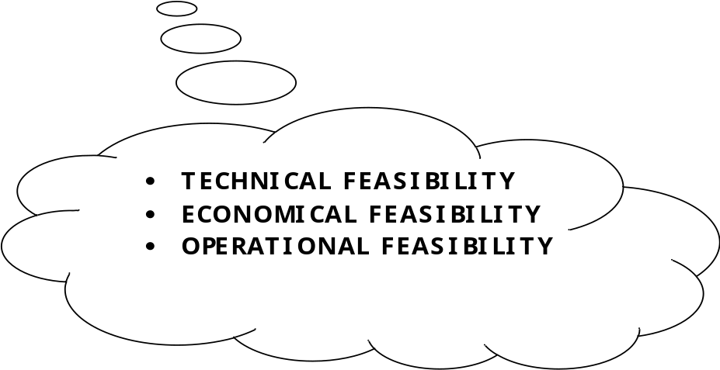

Feasibility Study

A feasibility study is conducted to select the best system that meets performance requirement. This entails an identification description, an evaluation of candidate system and the selection of best system for he job. The system required performance is defined by a statement of constraints, the identification of specific system objective and a description of outputs.

The key consideration in feasibility analysis are :

1. Economic Feasibility :

2. Technical Feasibility :

3. Operational Feasibility:

Economical feasibility

It looks at the financial aspects of the project. It determines whether the management has enough resources and budget to invest in the proposed system and the estimated time for the recovery of cost incurred. It also determines whether it is worth while to invest the money in the proposed project. Economic feasibility is determines by the means of cost benefit analysis.The proposed system is economically feasible because the cost involved in purchasing the hardware and the software are within approachable. The personal cost like salaries of employees hired are also nominal, because working in this system need not required a highly qualified professional. The operating-environment costs are marginal. The less time involved also helped in its economical feasibility. It was observed that the organization has already using computers for other purpose, so that there is no additional cost to be incurred for adding this system to its computers.
The backend required for storing other details is also the same database that is Sql. The computers in the organization are highly sophisticated and don’t needs extra components to load the software. Hence the organization can implement the new system without any additional expenditure. Hence, it is economically feasible.

- Software Cost :

Web Logic Server : 20000/-

Oracle : 15000/-

J2EE Kit : Free

- Manpower Cost :

Team cost : 25000/-

System Cost : 40,000/-

Total Cost : 100000/-

Technical Feasibility

It is a measure of the practically of a specific technical solution and the availability of technical resources and expertise

- The proposed system uses Java as front-end and Oracle 8.0 as back-end tool.
- Oracle is a popular tool used to design and develop database objects such as table views, indexes.
- The above tools are readily available, easy to work with and widely used for developing commercial application.

Hardware used in this project are- p4 processor 2.4GHz, 128 MB RAM, 40 GB hard disk, floppy drive. These hardware were already available on the existing computer system. The software like Oracle 8i, Weblogic Server, Thin Driver, JDK, JSDK, J2EE and operating system WINDOWS-XP’ used were already installed On the existing computer system. So no additional hardware and software were required to purchase and it is technically feasible. The technical feasibility is in employing computers to the organization. The organization is equipped with enough computers so that it is easier for updating. Hence the organization has not technical difficulty in adding this system.

Tools Used :

1) J2EE Library

2) J2SDK 2.0

3) JDK 1.2

4) WebLogic 8.1

- Oracle 8i.

Duration of Project:-

Time Duration

For study 15 days
Designing 20 days
For development 90 days
Testing 15 days

Total time 140 days

Operational Feasibility

The system will be used if it is developed well then be resistance for users that undetermined

- No major training and new skills are required as it is based on DBMS model.

- It will help in the time saving and fast processing and dispersal of user request and applications.

- New product will provide all the benefits of present system with better performance.

- Improved information, better management and collection of the reports.

- User support.

- User involvement in the building of present system is sought to keep in mind the user specific requirement and needs.

- User will have control over there own information. Important information such as pay-slip can be generated at the click of a button.

- Faster and systematic processing of user application approval, allocation of IDs, payments, etc. used had greater chances of error due to wrong information entered by mistake.
Behavioral Feasibility

People are inherent to change. In this type of feasibility check, we come to know if the newly developed system will be taken and accepted by the working force i.e. the people who will use it.

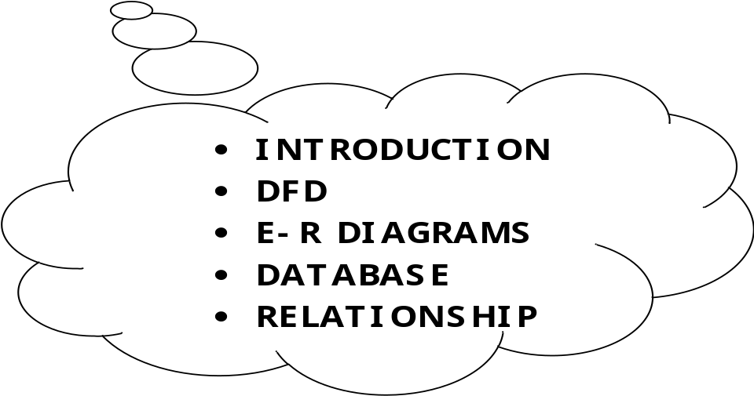

INTRODUCTION

SYSTEM DESIGN

Introduction
System design provides the understandings and procedural details necessary for implementing the system recommended in the system study. Emphasis is on the translating the performance requirements into design specifications. The design phase is a transition from a user-oriented document (System proposal) to a document oriented to the programmers or database personnel.
System design goes through two phases of development:

      - Logical Design
      - Physical Design

A data flow diagram shows the logical flow of the system. For a system it describes the input (source), output (destination), database (data stores) and procedures (data flows) all in a format that meets the user’s requirement. When analysis prepare the logical system design, they specify the user needs at a level of detail that virtually determines the information flow into an out of the system and the required data resources. The logical design also specifies input forms and screen layouts.
The activities following logical design are the procedure followed in the physical design e.g., producing programs, software, file and a working system. Design specifications instruct the user about what the system should do.

Logical and Output Design:
The logical design of an information system is analogous to an engineering blue print of an automobile. It shows the major features and how they are related to one another. The detailed specification for the new system was drawn on the bases of user’s requirement data. The outputs inputs and databases are designed in this phase.
Output design is one of the most important features of the information system. When the outputs is not of good quality the users will be averse to use the newly designed system and may not use the system. There are many types of output, all of which can be either highly useful or can be critical to the users, depending on the manner and degree to which they are used.
Outputs from computer system are required primarily to communicate the results of processing to users, They are also used to provide a permanent hard copy of these results for later consultation. Various types of outputs required can be listed as below:
- External Outputs, whose destination is outside the organisation
- Internal outputs, whose destination is with the organisation
- Operational outputs, whose use is purely with in the computer department e.g., program-listing etc.
- Interactive outputs, which involve the user is communicating directly with the computer, It is particularly important to consider human factor when designing computer outputs. End user must find outputs easy to use and useful to their jobs, Without quality output, user may find the entire system unnecessary and avoid using it. The term “Output” in any information system may apply to either printer or displayed information. During the designing the output for this system, it was taken into consideration, whether the information to be presented in the form of query of report or to create documents etc.

Other important factors that were taken into consideration are:
The End user, who will use the output.
- The actual usage of the planned information
- The information that is necessary for presentation
- When and how often output and their format is needed. While designing output for project based Attendance Compilation System, the following aspects of outputs designing were taken into consideration.
- The outputs (i.e., well formatted table outputs in the screen itself) designed are simple to read and interpret.
- Format of each output was another important point taken into consideration. Output media, for each output appropriate media is decided whether it will be displayed on screen or will be taken to printer or both.
- Other output design related specifications, i.e., how frequently the outputs will be generated, how many pages or sheets approximately it will keep up, what is its planned use and output distribution to users are also taken into account.
These were a few major designing issues, which were taken into consideration, while deciding the output specifications for the system. As direct beneficiary of reports is the user community, they were consulted constantly at every level. Formats and screen design for various reports were identified, taking into account the user requirements. Before finalising these were given to users for any improvement and suggestions. End users issues taken into consideration were Readability, Relevance and Acceptability.
Once all the output reports to be generated by ACS system were identified, they were given to users for their acceptance. For prototyping various outputs, final outputs models were created with dummy data, before they were finalised.

Output Sources:
Output contents originate from these sources:
- Retrieval from a data source.
- Transmission from a process or system activity.
- Directly from an input source.

The information produced in an output can be presented as
- Tabular contents
- Graphic format
- Using Icons

Output Definition:
The output should be defined in terms of:
Types of outputs
- Content-headings, numeric, alphanumeric, etc.,
- Format-hardcopy, screen, microfilm, etc.,
- Location-local, remote, transmitted, etc.,
- Frequency-daily, weekly, hourly, etc.,
- Response-immediate with in a period, etc.,
Data items
The name given to each data item should be recorded and its characteristics described clearly in a standard form:
- Whether alphanumeric or numeric
- Legitimate and specific range of characteristics
- Number of characters
- Positions of decimal point, arithmetic design, etc.,

Input Design:
The input design is the link that ties the information system into the user’s world. Input specifications describe the manner in which data enters the system for processing. Input design features can ensure the reliability of the system and produce results from accurate data, or they can result in the production of erroneous information.

Input Design consists of
- developing specifications and procedures for data preparation
- Steps necessary to put data into a usable form for processing.
- Data entry, the activity of putting data into the computer processing.

Objectives of Input design

Five objectives of design input focus on

- Controlling the amount of input required
- Avoid delay
- Avoiding errors in data
- Avoiding extra steps.
- Keeping the process simple.

Input stages several activities have to be carried out as part of te overall input process. They include some or all of the following.
Data recording (i.e., collection of data)
Data encapsulation(i.e.,transfer of data)
Data conversion(i.,e.,controlling the flow of data)
Data transmission(i.e.,transporting te data)
Data validation(i.e.,checking te input data)
Data correction(i.e.,correcting the errors)
Input Performa were designed, after a careful discussion with users. It was attempted to cover all user requirements. Designed Performa were given to user for any suggestion and final approval.
Various data items were identified and wherever necessary were recorded.
Input designs are aimed at reducing the chances of mistakes of errors. As the human beings are prone to errors there is always a possibility of occurrence of chance of errors. Adequate validation checks are incorporated to ensure error free data storage. Some of the data validation checks applied are as following:
- Redundancy of data is checked. It means the records of primary key do not occur twice.
- Primary key field of any table must not be left blank.
- Wherever items are coded, input code is checked for it’s validly with respect to several checks.

- Utmost care has been taken to incorporate the validation at each stage of the system. E.g. when entering records into employee information table for employee, it is checked that whether the corresponding employee exists in the employee information table etc.,
Enough messages and dialogue boxes are provided while design screen, which does guide user at the time of any errors, or at time of entry. This feature provides a user-friendly interface to native users. It can be emphasized that input deigns of HRRP is so designed that it ensures easy and error free data entry mechanism. Once one is sure of input data the output formatting becomes an routine work.

SOFTWARE DESIGN

The purpose of this phase is to plan a solution for the problem specified by the requirement document. This is first step in moving from the problem domain to solution domain. Designing activity is divided into two parts.

a) System Design
It aims to identify the modules that should be in the system, the specification of these modules and how they interact with each other to produce the desired result.

b) Detailed Design
The internal goal of each of the modules specified in the system design is decided

DATABASE DESIGN

A database is a collection of inter-related data stored with a minimum of redundancy to serve many applications. It minimizes the artificiality embedded in using separate files. The primary objectives are fast response time to enquires, more information at low cost, control of redundancy, clarity and ease of use, accuracy and fast recovery. The organization of data in a database aims to achieve three major objectives, they are data integration, data integrity and data independence. During the design of the database at most care has been taken to keep up the objectives of the database design.

CODE DESIGN

The process of code is to facilitate the identification and retrieve of items of information. The code should be simple and easy to understandable. The codes were designed in such a way that the features such as optimum human – oriented use and machine efficiency are unaffected.

For the code to be designed effectively, the following characteristics were also considered while designing the code.

- Uniqueness
- Versatility
- Stability
- Simplicity
- Consciousness

The code should be adequate for present and anticipated data processing for machine and human use. Care was taken to minimize the clerical effort and computer time required to continue operation.

PROCESS DESIGN

The process can be conceptualized in such a way to keep the methodology of main module process along with some auxiliary task, which will run concurrently with the main program.

The top-down approach is maintained so as to keep track of the process, which satisfies the maintenance reliability testing requirements. The concurrency of the data is checked during data entry, by means of validation check for data in each field.

DATA FLOW DIAGRAMS

DATA FLOW DIAGRAM

Data Flow Diagramming is a means of representing a system at any level of detail with a graphic network of symbols showing data flows, data stores, data processes, and data sources/destination.

The data flow diagram is analogous to a road map. It is a network model of all possibilities with different detail shown on different hierarchical levels. This processes of representing different details level is called “leveling” or “partitioning” by some data flow diagram advocates. Like a road map, there is no starting point or stop point, no time or timing, or steps to get somewhere. We just know that the data path must exist because at some point it will be needed. A road map shows all existing or planned roads because the road is needed.

Details that is not shown on the different levels of the data flow diagram such as volumes, timing, frequency, etc. is shown on supplementary diagrams or in the data dictionary. For example, data store contents may be shown in the data dictionary.

Data Flow Diagram (DFD) uses a number of symbols to represent the systems. Data Flow Diagram also known as ‘Bubble Chart’ is used to clarify system requirements and identifying the major transformations that will become programs in system design. So it is the starting point of the design phase that functionally decomposes the requirements specifications down to the level of details.

Terms used in DFD

- Process

A process transforms data values. The lowest level processes are pure functions without side effects. An entire data flow graphics high level process.

Graphical representation:
Graphical Representation: 

- Data flows

A data flow connects the output of an object or process to input of another object or process. It represents the intermediate data value within a computation. It is represented by an arrow and labeled with a description of data, usually its name or type.
Graphical Representation:

- Actors

An actor is active object that drives the data flow graph by producing or consuming values.

- Data store

A data store is a passive object with in a data flow diagram that stores data for later access.
Graphical Representation:

- External Entity

A rectangle represents an external entity such as a librarian, a library member.
Graphical Representation:
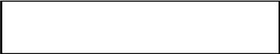

- Output Symbol

This box represented data production during human computer interaction

Graphical Representation:

LoveToShop

LoveToShop: (Main Module)
- ADMIN
- CUSTOMER
    - VISITOR
    - MEMBER
- ORDER TRACK

Module Name | Function | Benefits | Tables
ADMIN | - ADD NEW PRODUCT.  - CREATE NEW PRODUCT CATEGORY  - DELETE OR UPDATE EXISTING PRODUCT S  - CHECK ORDERS  - PLACE ORDERS TO DELIVERY  - DELIVERY UPDATE  - READ QUERY & RESPONSE  - MEMBER PAYMENT RECIVED ENTRY |  | - Products  - Product Detail  - Category  - Update Products  - Update Detail  - User  - Delivery
CUSTOMER |  |  | - Order  - Order Details
VISITOR | - BROWSE PRODUCTS BY CATEGORY  - ADD SELECTTED PRODUCTS TO CART  - UPDATE CART  - CHECKOUT  - ONLINE PAYMENT OPTIONS |  | - Visitor Order
MEMBER | - CREATE NEW MEMBER ACCOUNT  - LOGIN EXISTING MEMBER  - MEMBER UPDATE PROFILE  - BYE PRODUCTS ON ACCOUNT  - ORDERS REPORTS  - DELIVRY REPORTS  - PAYMENT REPORTS |  | - Member  - Member Orders  - Member Payments
ORDER TRACK | - CHECK ORDER STATUS ONLINE BY ORDER ID NUMBER  - SEND QUERY RELATED TO ORDER  - GET QUERY RESPONSE |  | - Query

DFD:

Context Level DFD:
Add & update products, category.
Delivery updates & Query Response

ADMIN
Get Queries.
Check Orders & Check Payments.

LoveToShop
(ONLINE SHOPING)

CUSTOMER

Browse Products.
Check Order Status Online.
Get Query Response

Add Products to Carts.
Place Orders & Make Payments.
Make Query

First Level DFD:
ADMIN

LoveToShop
(ONLINE SHOPING)

Check Order Status Online.
Get Query Response

Make Query
Add & update products, category.
Delivery updates & Query Response

Get Queries.
Check Orders & Check Payments.

Order Track

Add Products to Carts.
Place Orders & Make Payments.

Browse Products.

CUSTOMER
Create Account
Update Profile
Get Query Response
Get Payment Reports
Get Orders Reports
Get Delivery Reports

MEMBER
VISITOR

Second Level DFD (ADMIN):
Enter Username & Password
Process Login
Login

USER
ADMIN USER
I F LOGIN TRUE THEN ENTER TO ADMIN SECTION

Add update, delete Product & Product Category

PRODUCT
ADMIN SECTION

CATEGORY

Update Member Payment Receiving
MEMBER_PAYMENT
(External Entity)
Check Orders & Order Details

Get Query & Update Query Response

QUERY
Place Orders to Delivery & Update Delivery Status
Check Orders & Order Details
Get Member Details
DELIVERY
ORDER
(External Entity)
ORDER DETAIL
(External Entity)
MEMBER
(External Entity)

Second Level DFD (MEMBER):
Enter Username & Password
Process Login
Login

MEMBER
MEMBER USER
Get or Update Profile
I F LOGIN TRUE THEN ENTER TO MEMBER SECTION

MEMBER SECTION

Browse Products & Add to Cart and Place Cart to Order (Check Out)

PRODUCT
(External Entity)

CATEGORY
(External Entity)

Get Payment Details
MEMBER_PAYMENT
Make Query & Get Response
Get Delivery Status
Check Orders & Order Details
ORDER
(Derived Entity)
ORDER DETAIL
(Derived Entity)
DELIVERY
(External Entity)

QUERY

Second Level DFD (VISITOR):

VISITOR USER
ENTER TO VISITOR SECTION

VISITOR SECTION

Browse Products & Add to Cart and Place Cart to Order (Check Out)

PRODUCT
(External Entity)

CATEGORY
(External Entity)

Second Level DFD (ORDER TRACK):

CUSTOMER (VISITOR OR MEMBER)

ENTER ORDER_ID
FOR ENTERING TO THIS MODULE

ORDER TRACK SECTION

Make Query & Get Response
Get Delivery Status
Check Orders & Order Details
ORDER
(Derived Entity)
ORDER DETAIL
(Derived Entity)
DELIVERY
(External Entity)

QUERY

DATABASE:
Module (Admin);
1. Category:
Field Name | Data Type | Constraint | Description
Catid | Number | Primary key | This is a unique & not null column entire table
Description | Varchar2 |  | Description of the product Category
2. Product:
Field Name | Data Type | Constraint | Description
Pid | Number | Primary key | This is a unique & not null column entire table
Catid | Number | Foreign key | It refers to another table. category(catid)
Name | Varchar2 |  | Name or title of the product
Description | Varchar2 |  | Description of the product
Type | Varchar2 |  | Type of the product
PostingDate | Date |  | Posting date of the Product

3. Product Details:
Field Name | Data Type | Constraint | Description
Detail_id | Number | Primary key | This is a unique & not null column entire table
P_id | Number | Foreign key | It refers to another table. category(catid)
Color | Varchar2 |  | Color of the product
Weight | Varchar2 |  | Weight of the product
Size | Varchar2 |  | Size of the product
Image | Raw |  | Image of the product
NetPrice | Number |  | Net Price of the product
SellPrice | Number |  | Sell Price of the product

4. Product Update:
Field Name | Data Type | Constraint | Description
Update_id | Number | Primary key | This is a unique & not null column entire table
P_id | Number | Foreign key | It refers to another table. Product(catid)
Name | Varchar2 |  | Name or title of the product
Description | Varchar2 |  | Description of the product
Type | Varchar2 |  | Type of the product
Update_Type | Varchar2 |  | Type of operation( delete or update)
UpdateDate | Date |  | Date of the updation
5. Product Update Details:
Field Name | Data Type | Constraint | Description
Up_Detail_id | Number | Primary key | This is a unique & not null column entire table
Update_id | Number | Foreign key | It refers to another table ProductUpdate(upda_id)
Color | Varchar2 |  | Color of the product
Weight | Varchar2 |  | Weight of the product
Size | Varchar2 |  | Size of the product
Image | Raw |  | Image of the product
NetPrice | Number |  | Net Price of the product
SellPrice | Number |  | Sell Price of the product
6. Delivery:
Field Name | Data Type | Constraint | Description
Deli_id | Number | Primary key | This is a unique & not null column entire table
Order_id | Number | Foreign key | It refers to another table. Order (order_id)
Status | Varchar2 |  | Show the current status of the order delivery.
Deli_Date | Date |  | Date of the Order Delivery.
Deli_remark | Varchar2 |  | Any comment related to order delivery

7. User:
Field Name | Data Type | Constraint | Description
UserId | Varchar2 | Primary key | This is a unique & not null column entire table
Password | Varchar2 | Not null | It refers to another table. Order (order_id)
Typeoflogin | Varchar2 |  | Type of user login (admin or executive )

Module (Customer);
1. Order:
Field Name | Data Type | Constraint | Description
Order_id | Number | Primary key | This is a unique & not null column entire table
Order_type | Varchar2 |  | Type of the Order (Member or Visitor )
Date_Time | Varchar2 |  | Order date & time
Billing_Add | Varchar2 |  | Billing Address
1. OrderDetail:
Field Name | Data Type | Constraint | Description
O_Detail_id | Number | Primary key | This is a unique & not null column entire table
Order_id | Number | Foreign Key | It refers to order table (order id) column.
P_Detail_id | Number | Foreign Key | It refers to product Detail table (p_detail id)
Qty | Number |  | Product quantity

Module (Visitor);
1. Visitor Order:
Field Name | Data Type | Constraint | Description
V_Order_id | Number | Primary key | This is a unique & not null column entire table
Order_Id | Number | Foreign Key | It refers to order table (order id) column.
Name | Varchar2 |  | Name of the visitor
Address | Varchar2 |  | Address of the visitor
Phone | Number | Check | Visitor phone number
Mobile | Number |  | Visitor Mobile Number
Email | Varchar2 |  | Visitor email address
Payment | Varchar2 |  | Payment option
Payment_details | Varchar2 |  | Payment details

Module (Member);
1. Member Order:
Field Name | Data Type | Constraint | Description
M_Order_id | Number | Primary key | This is a unique & not null column entire table
Order_Id | Number | Foreign Key | It refers to order table (order id) column.
Mem_id | Number | Foreign Key | It refers to member table (mem_id) column.
2. Member:
Field Name | Data Type | Constraint | Description
Mem _id | Number | Primary key | This is a unique & not null column entire table
Name | Varchar2 |  | Name of the member
Address | Varchar2 |  | Address of the member
Phone | Number | Check | member phone number
Mobile | Number |  | member Mobile Number
Email | Varchar2 |  | member email address
Balance | Number |  | Member account balance
Password | Varchar2 |  | Login password
SequrityQuestion | Varchar2 |  | Password recovery secured question
SequrityAns | Varchar2 |  | Password recovery secured answer

3 Member Payments:
Field Name | Data Type | Constraint | Description
Payment_id | Number | Primary key | This is a unique & not null column entire table
Mem _id | Number | Foreign key | It refers to another table member(memid)
PayOption | Varchar2 |  | Payment option( cash deposit, online, credit cards)
PayDetails | Varchar2 |  | Details of the payment
Amount | Number |  | Amount of payment
Payment_Date | Varchar2 |  | Date & time of the payment

Module (Order Track);
1. Query:
Field Name | Data Type | Constraint | Description
Query_id | Number | Primary key | This is a unique & not null column entire table
Order_Id | Number | Foreign Key | It refers to order table (order id) column.
Query | Varchar2 |  | Query Question
QueryDateTime | Varchar2 |  | Query generation Date & time
Response | Varchar2 |  | Query Response
ResDateTime | Varchar2 |  | Response generation Date & time

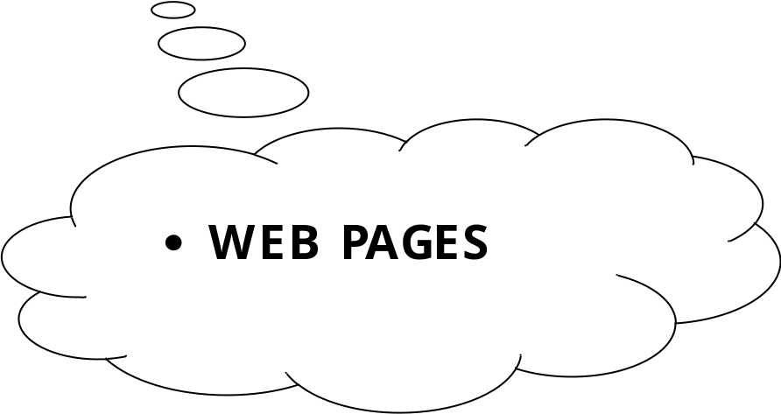

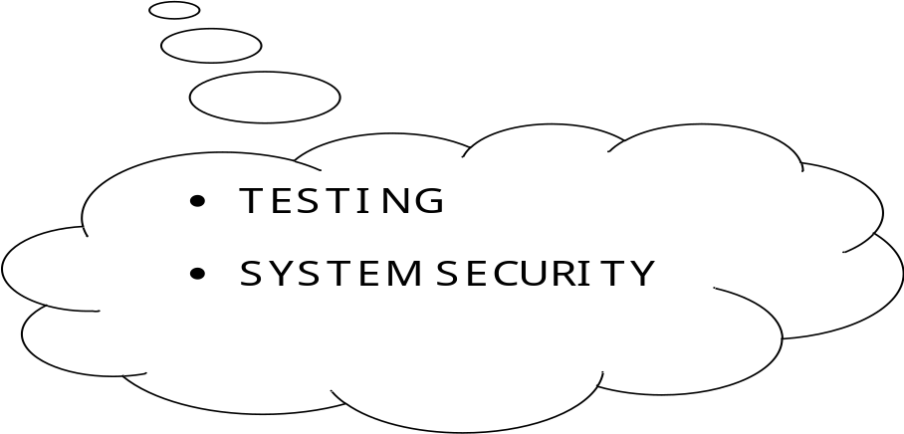

TESTING

SYSTEM TESTING

Here the System testing involved is the most widely used testing process consisting of five stages as shown in the figure. In general, the sequence of testing activities is component testing, integration testing, and then user testing. However, as defects are discovered at any one stage, they require program modifications to correct them and this may require other stages in the testing process to be repeated.

Unit testing
Module testing
Acceptance testing
Sub-system testing
System testing

(Component testing) (Integration testing) (User testing)

Testing is the process of detecting errors. Testing performs a very critical role for quality assurance and for ensuring the reliability of the software. The results of testing are used later on during maintenance also.

Testing is vital to the success of the system. System testing makes a logical assumption that if the parts of the system are correct, the goal will be successfully achieved. In adequate testing or non-testing leads to errors that may not appear until months or even years later (Remember the New York three day power failure due to a misplaced ‘Break’ statement).

This creates two problems:
- The time lag between the cause and the appearance of the problem.
- The time interval effect of the system errors on files and the records on the system.

A small error can conceivably explode into a much larger problem. Effective testing early in the process translates directly into long term cost savings from a reduced number of errors.

Another reason for system testing is it’s utility as a user oriented vehicle before implementation. The best program is worthless if it does not meet the user requirements. Unfortunately, the user’s demands are often compromised by efforts to facilitate program or design efficiency in terms of processing time or design efficiency.

Thus in this phase we went to test the code we wrote. We needed to know if the code compiled with the design or not? Whether the code gave the desired outputs on given inputs? Whether it was ready to be installed on the user’s computer or some more modifications were needed?

Through the web applications are characteristically different from there software counterparts but the basic approach for testing these web applications is quite similar. These basic steps of testing have been picked from software engineering practices. The following are the steps, we undertook:

- The content of the Intranet site is reviewed to uncover Content
Errors. Content Errors covers the typographical errors, grammatical errors, errors in content consistency, graphical representation and cross referencing errors

- The design model of the web application is reviewed to uncover the navigation errors. Use cases, derived as a part of the analysis activity allows a web designer to exercise each usage scenario against the architectural and navigational design. In essence these non-executable tests help to uncover the errors in navigation.

- When web applications are considered the concept of unit changes. Each web page encapsulate content navigation links, content and processing elements(Forms, Scripts, JSP’s as in our case). It is not always possible to test each of these individually. Thus is the base of the web applications the unit to be considered is the web page. Unlike the testing of the algorithmic details of a module the data that flows across the module interface, page level testing for web applications is driven by content, processing and links encapsulating the web page.

- The Assembled web application is tested for overall functionality and content delivery. the various user cases are used that test the system for errors and mistakes.

- The Web application is tested for a variety of environmental settings and is tested for various configurations and upon various platforms.
The modules are integrated and integration test are conducted.

- Thread based testing is done to monitor the regression tests so that the site does not become very slow is a lot of users are simultaneously logged on.

- A controlled and monitored population of end users tests Intranet application , this all comprises of the User Acceptance Testing .

Because web application evolve continuously , the testing process is an ongoing activity, conducted by web support staff in our case the Organization’s IS people who will finally update and manage the application.

PSYCHOLOGY OF TESTING

The aim of testing is often to demonstrate that a program works by showing that it has no errors. The basic purpose of testing phase is to detect the errors that may be present in the program. Hence one should not start testing with the intent of showing that a program works, but the intent should be to show that a program doesn’t work. Testing is the process of executing a program with the intent of finding errors.

TESTING OBJECTIVES:

The main objective of testing is to uncover a host of errors, systematically and with minimum effort and time. Stating formally, we can say,

- Testing is a process of executing a program with the intent of finding an error.
- A successful test is one that uncovers an as yet undiscovered error.
- A good test case is one that has a high probability of finding error, if it exists.
- The tests are inadequate to detect possibly present errors.
- The software more or less confirms to the quality and reliable standards.

LEVELS OF TESTING

In order to uncover the errors present in different phases, we have the concept of levels of testing. The basic levels of testing are

Client Needs Acceptance Testing

Requirements System Testing

Design Integration Testing

Code Unit Testing

Unit testing

Unit testing focuses verification effort on the smallest unit of software i.e. the module. Using the detailed design and the process specifications, testing is done to uncover errors within the boundary of the module. All modules must be successful in the unit test before the start of the integration testing begins.
In this project each service can be thought of a module. There are so many modules like Login, HR Department, Interviewer Section, etc. Each module has been tested by giving different sets of inputs. When developing the module as well as finishing the development, the module works without any error. The inputs are validated when accepting them from the user.

Integration Testing

After unit testing, we have to perform integration testing. The goal here is to see if modules can be integrated properly, the emphasis being on testing interfaces between modules. This testing activity can be considered as testing the design and hence the emphasis on testing module interactions.

In this project the main system is formed by integrating all the modules. When integrating all the modules I have checked whether the integration effects working of any of the services by giving different combinations of inputs with which the two services run perfectly before Integration.

SYSTEM TESTING

Here the entire software system is tested. The reference document for this process is the requirements document, and the goal is to see if software meets its requirements.
Here entire ‘HRRP’ has been tested against requirements of project and it is checked whether all requirements of project have been satisfied or not.

ACCEPTANCE TESTING

Acceptance Testing is performed with realistic data of the client to demonstrate that the software is working satisfactorily. Testing here is focused on external behavior of the system; the internal logic of program is not emphasized.

Test cases should be selected so that the largest number of attributes of an equivalence class is exercised at once. The testing phase is an important part of software development. It is the process of finding errors and missing operations and also a complete verification to determine whether the objectives are met and the user requirements are satisfied.

WHITE BOX TESTING

This is a unit testing method, where a unit will be taken at a time and tested thoroughly at a statement level to find the maximum possible errors.

I tested step wise every piece of code, taking care that every statement in the code is executed at least once. The white box testing is also called Glass Box Testing.

I have generated a list of test cases, sample data, which is used to check all possible combinations of execution paths through the code at every module level.

White-box test focuses on the program control structure. Test cases are derived to ensure that all statement in the program control structure. Test cases are derived to ensure that all statement in the program control structure. Test cases are derived to ensure that all statement in the program has been executed at least once during testing and that all logical conditions have been exercised. Basis path testing, a white box technique, makes use of program graphs (or graph matrices) to derive the set of linearly independent test that will ensure coverage. Condition and data flow testing further exercising degrees of complexity.

BLACK BOX TESTING
This testing method considers a module as a single unit and checks the unit at interface and communication with other modules rather getting into details at statement level. Here the module will be treated as a block that will take some input and generate output. Output for a given set of input combinations are forwarded to other modules.
Black-box test are designed to uncover errors functional requirement without regard to the internal workings of a program. Black-box testing techniques focus on the information domain of the software, deriving test cases by partitioning the input and output domain of a program in manner that provides through test coverage. The black-box test is used to demonstrate that software functions are operational, that input is properly produced, and that the integrity of external information are maintained. A black-box test examines some fundamental aspect of a system with little or no regard for the integral logical structure of the software.

Graph based testing methods explore the relationship between and behavior of program objects. Equivalence partitioning divides the input classes of data are likely to exercise specific software function. Boundary values analysis probes the program’s ability to handle data at the limits of acceptability.

TEST INFORMATION FLOW
A strategy for software testing may also be viewed in the context of the spiral. Unit testing begins at the vortex of the spiral and, concentrates on each unit, component of the software as implemented in source code. Testing progresses moving outward along the spiral to integration testing, where the focus is on designed the construction of the software architecture. Taking another turn outward on spiral, we encounter validation testing, where requirements established as part of software requirements analysis are validated against the software that has been constructed. Finally, we arrive at system testing, where the software and other system elements are tested as a whole. To test computer software, we spiral out along stream lines that broaden the scope of testing with each turn.

Considering the process from a procedural point of view, testing within the context of software engineering is actually a series of four steps that are implemented sequentially. The steps are shown in Figure. Initially, tests focus on each component individually, ensuring that it functions properly as unit. Hence, the name unit testing. Unit testing makes heavy use of white-box testing techniques, exercising specific paths in module’s control structure to ensure complete coverage and maximum error detection.

System Testing

System Engineering

Validation Testing

Integration Testing

Design

Validation testing

Code

System Security

6.3 INFORMATION FLOW OF DATA FOR TESTING

Evaluation

Software Configuration
Test Results

Testing
Error

Debug
Error Rate Data
Expected Results

Reliability Model

Test Configuration
Predicated Reliability

Correction

SYSTEM SECURITY

SYSTEM SECURITY

Introduction

One might think that there is a little reason to be concerned about security in an intranet. After all, by definition an intranet is internal to ones’ organization; outsider can not access it. There are strong arguments for the position that an intranet should be completely open to its users, with little or no security. One might not have considered ones’ intranet on any other light.
On the other hand, implementing some simple, built-in security measures in ones’ intranet can allow one to provide resources one might not have considered possible in such context. For example, one can give access to some Web Pages to some people without them available to oner entire customer base, with several kinds of authentication.

Intranet security is, then, a multifaceted issue, with both opportunities and dangers, especially if ones’ network is part of the Intranet.

There are basically two types of security associated with this system:

1. Physical security:-

Damage due to natural causes like earth tremor, flooding, water logging, fire hazards, atmospheric or environmental conditions etc..For overcoming these difficulties the replica of the data are automatically stored at various networks and for environmental conditions Air conditioning environment is created.

2. Data security:-

There are basically two problems associated with data security:-
a). Data not being available to the authorized person at the time of need.

b). Data becoming available to the unauthorized person.

To overcome these difficulties the following access facilities has been provided:-

i) Identification:-
Unique Ids for the different users have been provided.

ii) Authentication:-
System checks the password under the particular user identification. The computer permits the various resource to the authorized person.

iii) Authorisation:-
The access control mechanism to prevent unauthorized logging to the system.

Need for Security

Many people view computer and network security in a negative light, thinking of it only in terms of restricting access to services. One major view of network security is “that which is not expressly permitted is denied.” Although this is a good way of thinking about how to connect other organization to the internet, one can, and possibly should, view intranet security from a more positive angle. Property set up, intranet security can be an enabler, enriching ones’ intranet with services and resources one would not otherwise be able to provide. Such an overall security policy might be described as “that which is not expressly denied is permitted.”

This does not mean that one should throw caution to the wind and make everything available to ones’ users on ones’ intranet. There are many things to consider when placing sensitive business data out on ones’ intranet. It may fall into the wrong hands, or worse, be used against ones’ business. For example, some of ones’ users might have information they would li9ke to make available, provided access to it can be limited to a specified group-for example, confidential management or financial information. Without the ability to ensure that only those who have the right to see such information will have access, the custodians of data will not be willing to put it on ones’ intranet. Providing security increases ones’ organization’s ability to use the important collaborative aspects of an intranet.

The more defensive approach, preventing abuse of ones’ intranet, is also given play, however. Organizations’ needs for security in an intranet can vary widely. Businesses in which confidentiality and discretion are the norm in handling proprietary information and corporate intellectual property have different needs than a college or university, for example. Academic institutions generally tilt toward making the free exchange of ideas a primary interest. At the same time, though the curiosity (to use a polite word) of undergraduates requires strong needs for security. Keeping prying sophomores out of university administration computing resources is a high priority; for example, students have been known to try to access grade records(their own or those of others) for various reasons.

Security Features of an Intranet:-

Before going into a great deal of detail about how one can use security to enhance ones’ intranet, take a high- level look at what security features are available to ones. These break down into three main categories.

First, one can take steps on ones’ Web server to set up security. Second, one can take steps with the other TCP/IP network services one has set up on ones’ intranet to enhance their security. Third, one can secure customers’ Web browsers themselves to limit what they can do with them.

a) Web server Security

There is a wide range of very flexible security features one can implement on ones’ Web server. Here’s a summary:

- Access to Web servers, individual Web pages, and entire directories containing Web pages can be set to require a username and password.
- Access to Web servers, individual Web pages, and entire directories containing Web pages can be limited to customers on specific computer systems. (In other words, access will be denied unless the user is at his or her usual computer or workstation.)
- One can organize individuals into groups and grant access to individual Web servers, Web pages, and entire directories containing Web pages based on group membership.
- One can organize computers into groups, and grant access to individual Web servers, Web pages, and entire directories containing Web pages based on group membership.

It’s ones’ responsibility to determine the level of security one need on ones’ intranet, and, of course, to implement it. Putting most of the security measures mentioned into place is not difficult. Ones’ primary concern will be explaining to customers how intranet security works, not so much as a limiting factor but as an opportunity for increased use and collaboration using ones’ intranet. Assuring decision-makers that they can make information available on ones’ intranet in a secure fashion can go a long way toward making ones’ intranet a success. At the same time, it’s important to make sure both information providers and their customers understand a number of critical aspects of intranet security, so they don’t inadvertently defeat the purpose of it.

There are network security commonplaces, unrelated to intranet security specifically, that need ones’ attention. All the security precautions in the world can’t protect ones’ intranet from overall poor security practices. Users making poor choices on passwords always lead the list of computer and network security risks. One can limit access to a sensitive Web resources based on the TCP/IP network address of boss’s pc, but if the boss walks away and leaves his pc unattended without an active screen lock, anyone who walks into the empty office can access the protected resources.

b) An Important Warning About Hostname/ IP Address Authentication

All of the Web server software described in this chapter trustingly accepts the word of a requesting computer when it sends its IP address. Verification of this information is not possible. It’s relatively easy for a user to change the hostname/IP address of a UNIX system, and laughably easy to change that of a pc or Mac. A curious, mischievous, or malicious person can reconfigure his computer to impersonate someone else’s simply by changing the IP address of his own. Although this is an overall network security issue, not specifically one for ones’ intranet, it’s important one Know about it because it can affect the security of ones’ access controlled documents. Security-minded network administrators can use special hardware and software to prevent this sort of IP spoofing, but for ones’ intranet, one’ll probably want to combine hostname/IP address authentication with username/password authentication, as outlined in the following section.

c) Secure/ Encrypted Transactions

One can further enhanced security on ones’ intranet by encrypting Web transactions. When one use an encryption facility, information submitted by customers using Web fill-in forms-including usernames, passwords, and other confidential information-can be transmitted securely to and from the Web server.

d) Intranet and the Internet

Is ones’ intranet is accessible from the internet? If so, all of the security problems of the Internet are now ones’ intranet’s problems, too. One can, however, connect safely to the Internet and still protect ones’ intranet. One can even use the Internet as a means of letting remotes sites in ones’ company access ones’ intranet.

e) Firewalls

It’s a fact of Internet life there are people out there who want to break into other people’s networks via the Internet. Reasons vary from innocent curiosity to malicious cracking to business and international espionage. At the same time, the value of Internet to organizations and businesses is as great that vendors are rushing to fill the need for Internet security with Internet firewalls. An Internet firewall is a device that sits between ones’ internal network and outside Internet. Its purpose is to limit access into and out of ones’ network based on ones’ organization’s access policy.

A firewall can be anything from a set of filtering rules set up on the router between one and the Internet to an elaborate application gateway consisting of one or more specially configured computers that control access. Firewalls permit desired services coming from the outside, such as Internet e-mail, to pass. In addition, most firewalls now allow access to the World Wide Web from inside the protected networks. The idea is to allow some services to pass but to deny others. For example, one might be able to use the Telnet utility to log into systems on the Internet, but users on remote systems cannot use to log into ones’ local system because of the firewall.

Summary

Security is important not so much because it prevents things, but because it enables them. Judicious use of built-in security features of the Web server and other intranet resources can add value to ones’ intranet by making new things possible.

QUALITY ASSURANCE

QUALITY ASSURANCE

INTRODUCTION

The key factor to the success in software quality program is its implementation. While definition of process can be evolving phenomenon, implementation of processes makes the difference between success & failure.
A quality product can be defined as:
- One that is fit for use.
- One that is produced as per the predefined standards.
So, Software Quality Assurance is the process of ensuring that the product confirms to its standards.

QUALITY MANAGEMENT SYSTEM

A Quality Management System (QMS) is instituted by an organization to manage & maintain quality procedures in its day-to-day functioning. It is a conglomerate of people who have the required authority, responsibility and procedures for performing various activities. The QMS of an organization is guided by quality policy & quality procedures supported by various documents-Forms/Formats to maintain records & work instructions to provide guidelines for doing a particular piece of work.

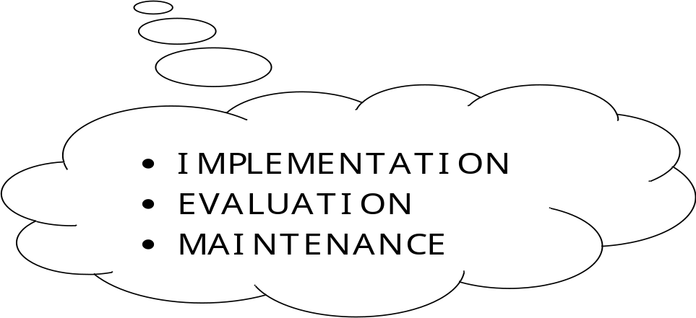

IMPLEMENTATION

IMPLEMENTATION

Introduction

System implementation is the stage when the user has thoroughly tested the system and approves all the features provided by the system. The various tests are performed and the system is approved only after all the requirements are met and the user is satisfied.

The new system may be totally new, replacing an existing manual or automated system, or it may be a major modification to an existing system. In either case, proper implementation is essential to provide a reliable system to meet organizational requirements. Successful implementation may not guarantee improvement in the organization using the new system (that is a design question), but improper will prevent it.

Implementation is the process of having systems personnel check out and put new equipment into use, train users, install the new application and construct any files of data needed to use it. This phase is less creative than system design. Depending on the size of the organization that will be involved in using the application and the risk involved in its use, systems developers may choose to test the operation in only one area of the firm with only one or two persons. Sometimes, they will run both old and new system in parallel way to com-pare the results. In still other situations, system developers stop using the old system one day and start using the new one the next.

The implementation of the web based or lan based networked project has some extra steps at the time of implementation. We need to configure the system according the requirement of the software.
For the project we need to install and configure Weblogic server 8.1 , database server, and the deployment directory for the project.

Aspects of Implementation

The two aspects of implementation are:

- Training Personnel
- Conversion Procedures

TRAINING

Even well designed and technically elegant systems can succeed or fail because of the way they are used. Therefore the quality of the training received by the personnel involved with the system in various ways helps or hinders, and may even prevent, the successful implementation of an information system.
Since, Human Resource Recruitment Process is web-based and user friendly, not much effort was required in training process.

CONVERSION:

Conversion is the process of changing from the old system to the new system. There are two methods of handling systems conversion:
- Parallel Run
- Immediate cut-off

Parallel Run

In this approach, the old system and the new system are used simultaneously for some period of time so that the performance of the new system can be monitored and compared with that of the old system. Also in case of failure of the new system, the user can fall back on the old system. The risk of this approach is that the user may never want to shift to new system.

      - Immediate cut-off

In this method, the use of the old system ceases as soon as the new system is implemented and bought in to palace. The old system becomes redundant from the day of implementation of the new system. There is the high risk involved in this approach if the new system is not tested rigorously. This is because of the fact that if the new system fails, then there will not be anything to fall back upon. The advantage of this approach is that both the systems need not be used simultaneously.

Implementation Tools

The project was implemented using Java server pages,HTML,Java beans.The implementation work was carried out in Windows XP/2000 server platform.

- J2EE
- Weblogic 8.1
- Oracle 8i

Coding

This means program construction with procedural specifications has finished and the coding for the program begins:

- Once the design phase was over,coding commenced

- Coding is natural consequence of design.

- Coding step translate a detailed design representation of software into a programming languae realization.

- Main emphasis while coding was on style so that the end result was an optimized code.

The following points were kept into cosideration while coding:

Coding Style

The structured programming method was used in all the modules the project.It incorporated the following features

- The code has been written so that the definition and implementation of each function is contained in one file.
- A group of related function was clubbed together in one file to include it when needed and save us from the labour of writing it again and again.

Naming Convention:-

- As the project size grows,so does the com[plexity of recognizing the purpose of the variables.Thus the variables were given meaningful names,whihch would hellp in understanding the context and the purposse of the variable.
- The function names are also given meaningful names that can be easily understood by the user.

Indentation

Judicious use of indentation can make the task of reading and understanding a program much simpler.Indentation is an essential part of a goog program.If code id intended without thought itv will seriously affect the readability of the program.

- The higher-level statements like he definition of the variables,constants and the function are intended,with each nested block intended,stating their purpose in the code.

- Blank line is also left between each function definition to make the code look neat.

- Indentation for each source file stating he purpose of the file is also done.

MAINTENANCE

MAINTENANCE

Maintenance or enhancement can be classified as: -

- Corrective
- Adaptive
- Perfective.

Corrective maintenance means repairing processing or performance failures or making changes because of previously uncorrected problems or false assumptions.

Adaptive maintenance means changing the program function.

Perfective maintenance means enhancing the performance or modifying the program(s) to respond to the user’s additional or changing needs.

Maintenance is actually the implementation of the post implementation review plan.

As important as it is, many programmers and analysts are reluctant to perform or identify themselves with the maintenance effort. There are psychological, personality and professional reasons for this. In any case, a first class effort must be made to ensure that software changes are made properly and in time to keep the system in tune with user specifications.

Maintenance is costly. One way to reduce maintenance costs is through maintenance management and software modification audits. Software modification consists of program rewrites system level updates, and re-audits of low ranking programs to verify and correct the soft spots.

The outcome should be more reliable software, a reduced maintenance backlog, and higher satisfaction and morale among the maintenance staff.

In HRRP, care has been taken towards maintenance; Loop Holes can be eradicated from the system from time to time according to changing requirements with lesser cost.

EVALUATION

EVALUATION
The evaluation phase ranks vendor proposals and determines the one best suited, Evaluation of the system is performed to identify its strengths and weaknesses. The actual evaluation can occur along any of the following dimensions:

- Operational Evaluation: Assessment of the manner in which the system functions, including case of use, response time, overall reliability and level of utilization.

- Organizational Impact: Identification and measurement of benefits to the organization in such areas as financial concerns, operational efficiency and competitive impact.

- User Manager Assessment Evaluation of the attitudes of senior and user manager within the organization, as well as end-users.

- Development Performance: Evaluation of the development process in accordance with such yardsticks as overall development time and effort, conformance to budgets and standards and other project management criteria.

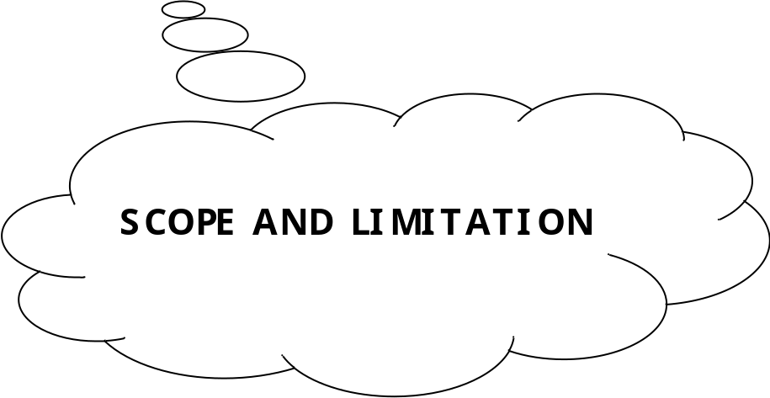

CONCLUSIONS

As evidence of the success of this mission, there are millions of items listed each day in thousands of different categories. There are items for almost any interest that one could imagine, from sheet music to automobiles to hand tools to real estate. And the variety doesn’t stop there. Need a computer? One may find it listed in the proper category, in any configuration from very old and obsolete to the latest greatest machine available. What about antiques? One can find an antique quilt that is up for highest bid, or maybe an old violin, whose beautiful tones have enchanted many though its years. Tickets. Maybe a ticket to the next concert of ones favorite artist or play production. One can even find that special bottle of wine, some aged, exotic cheese, and the perfect ‘mood’ music for that special occasion.

In this instance it may be true that on eBay, they have something for everybody, whatever their tastes may be.

Scope for Future Work

Since this system has been generated by using Object Oriented programming, there are many chances of reusability of the codes in other environment even in different platforms. Also its present features can be enhanced by some simple modification in the codes so as to reuse it in the changing scenario.

The site is made in all possible way to meet the user requirements using latest version of available software and hardware.But as user requirements and operating environment keep changing further extensions can be made on this.In future some more schemas can be added in the “HR Recruitment Process” hence these schemas are to be included in the software developed.

Limitations

Since, every system has some limitations so our proposed system is also not untouchable in this regard. Although it includes every kind of features, but it can’t be used in a huge organization where number of networks are very large, because the database used in this system is an average one. Also it doesn’t have different kind of access feature for different users.

Though it was planned for this system to be absolutely perfect but everything as such has some limitations, so does the System. Following may be the drawback in this system.

- Though this system is developed as a multi user system but it is not a real time system.
- The interaction with the database, every time they are loaded thus the system tends to be a bit slow.

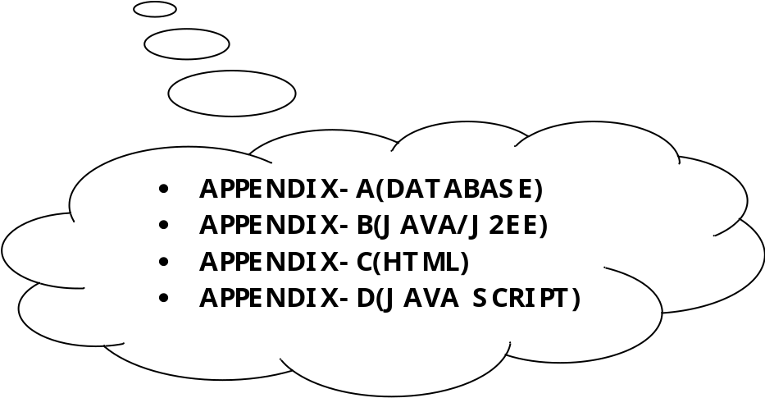

APPENDIX-A

APPENDIX-A

Backend remains on server side and has two components i.e.
- Server side program
- Data Base.

Data base is the most important thing in this universe as data base gives identity to a thing without data base existence of a thing is impossible while working on a project first step is to design a database.

What is data base ?

Data Base is a collection of tables and table is a collectionof records in a tabular form i.e. in row and columns.

Data Base can be divided into two parts :-

- RDBMS.

- DBMS.

We will be using RDBMS (Relational Database Management System) in our project i.e. oracle 8i Enterprise edition.

Why we are using Oracle (RDBMS)?

Some of the merits of using Oracle (RDBMS) is as under :-

- Centralization of database.
- Client Server Technology.
- Security.
- Normalization of Data Base.
- Relationship.
- Transaction Processor.
- It gives some internet related features.

Hence because of these features we are using Oracle as a back end technology.

ABOUT ORACLE 8i

Oracle 8i contains all the features of previous version. It also supports some new features & enhancement to some existing features. Oracle servers provides deficient & effective solution for the major features.

Large Database & Space Management Control

Many Concurrent Database Performances

High Transaction Processing Performance

High Availability

Controlled Availability

Industry Accepted Standards

Manageable Security

Database Enforced Integrity

Distributed Database System

Portability

Compatibility

Connectivity

NEW FEATURES OF ORACLE 8i

Improved Scalability

Improved Security

Improved Performance Via Partition

Enhanced Support for Database Replication

Capability To Handle a Much Larger Number Of Concurrent Users

New & Improved Data Types

APPENDIX-B

APPENDIX-B

What is Middle Ware?

Middle Ware is a concept, Middle Ware provides centralization of business logic i.e. instead of putting logic on each and every client machine we put logic on a centralized server hence middle ware is nothing but a server side program where all your business logic and business methods reside. It remains on server side and it has all the logical building. Middle ware provides:-

- Multiple Client access.
- Centralized business logic in case of distributed application.

Because we are working on Distributed Application Based Project we need platform independent Language:-

Technology Used

Introduction to Java

Java is a high level, third-generation programming language, like C, Fortran, Perl and many others. It is a platform for distributed computing – a development and run-time environment that cointains built-in support for the World Wide Web.

History of Java

Java development began at Sun Microsystems in 1991, the same year the World Wide Web was conceived. Java’s creator, James Gosling did not design java for the Internet. His Objective was to create a common development environment for consumer electronic devices which was easily portable from one device to another.
This effort evolved into a language , code named Oak and later renamed Java that retains much of the syntax and power of c++ , but is simpler and more platform independent.

Java Features

Some of the important features of Java are as follows:

- Simplicity
- Orientation
- Platform Independence
- Security
- High Performance
- Multi Threading
- Dynamic linking.
- Garbage Collection.

One of the most important features of Java is Platform Independence which makes it famous and suitable language for World Wide Web.

Why java is Platform Independent?

Java is Platform Independent because of Java Virtual Machine (JVM).

Java Virtual Machine (JVM)

The client application or operating system must have a java byte-code interpreter to execute byte-code instructions. The interpreter is a part of a lager program called the JVM. The JVM interprets the byte code into native code and is available on a platform that supports java.

Connectivity using JDBC

There are four kind of drivers available in Jdbc:-

- JdbcOdbc Bridge Driver.
- Partly Java Driver.
- Pure Java Driver.
- Native Driver.

Client Side Interface:

In client side interface we are using:-

Servlet / JSP – In Internet Based Application.

J2EE Framework and Architecture

J2EE is one of the best solutions that we have had so far for meeting the demand of today’s enterprise. J2EE specifies both the infrastructure for managing our applications, and the service APIs for building our applications.

The J2EE platform is essentially a distributed application-server environment- a java environment that provides the following: -

- A set of java extension APIs to build applications. These APIs define a programming model for J2EE applications.

* A run time infrastructure for hosting and managing applications. This is the server runtime in which our applications resides.

The applications that we could develop with the above may be programs to drive web pages, or components to implement complex database transactions, or even java applets, all distributed across the network.

The J2EE Runtime

While J2EE bundles together APIs that have been in existence in one form or another for quite sometime, perhaps its most significant aspect is the abstraction of the runtime infrastructure. The J2EE specification doesn’t specify how a J2EE runtime should or could be built. Instead, J2EE specify roles and interfaces for applications, and the runtime onto which applications could be deployed. This results in a clear demarcation between applications and the runtime infrastructure. This demarcation allow the runtime to abstract most of the infrastructure services that enterprise developers have traditionally attempt to build on their own. As a result, J2EE application developers could just focus on the application logic and related service, while leveraging the runtime for all infrastructure-related services.

Apart from specifying a set of standard APIs, the J2EE architecture also provides a uniform means of accessing platform-level services via its runtime environment. Such service includes distributed transactions, security, messaging etc.

The J2EE APIs Used

Distributed applications require access to a set of enterprise services. Typical services include transaction processing, database access, messaging, multithreading etc. The J2EE architecture unifies access to such services in its enterprise service APIs. However, instead of having to access these service through proprietary or non standard interfaces, application programs in J2EE can access these APIs via the container.
There are various API specification in J2EE framework which enable us to create an application at great speed with minimum effort.

APIs Used To Build the Software

- JDBC API

The JDBC API provides developers with a way to connect to relational data from within java code. Using the JDBC API, developers can create a client (which can be anything from an applet to an EJB) that can connect to a database, execute structured query language statements, and processes the result of those statements. The API provides connectivity and data access across the range of relational databases. It can do this because it provides a set of generic database access methods for sql compliant relational databases. JDBC generalizes the most common database access functions by abstracting the vendor specific detail of particular database. The result is set of classes and interface, placed in the java.sql package, which can be used with any database that has an appropriate JDBC drive. This allow JDBC connectivity to be provided in a consistent way for any database. It also means that with a little care to ensure the application confirms to the most commonly available database features, an application can be use with a different database simple by switching to a different JDBC driver. JDBC includes following packages for the means of database accessing and provides various features of the database. The packages are as follows: -

- java.sql Package: -

This package contains classes and interfaces designed with traditional client/server in mind. Its functionality is focused primarily on basic database programming services such as creating connections, executing statements and prepared statements, and running batch queries. Advanced functions such as batch updates, scrollable result sets, transaction isolation, and sql data types are also available.

- javax.sql Package: -

This package introduces sum major architectural change to JDBC programming compared to java.sql package, and provides better abstractions for connections management, distributed transactions, and legacy connectivity. This package also introduces container-managed connection pooling, distributed transactions, and row sets.

- Java Servlets: -

Servlets are Java technology’s answer to Common Gateway Interface (CGI)
programming. They are programs that run on a Web server, acting as middle
layer between a request coming from a Web browser or other HTTP client
and databases or applications on the HTTP server. Their job is to:

Read any data sent by the user.

This data is usually entered in a form on a Web page, but could also come from a Java applet or a custom HTTP client program.

Look up any other information about the request that is embedded in the HTTP request.

This information includes details about browser capabilities, cookies, the host name of the requesting client, and so forth.

Generate the results.

This process may require talking to a database, executing an RMI or CORBA call, invoking a legacy application, or computing the response directly.

Format the results inside a document.
In most cases, this involves embedding the information inside an HTML page.

Set the appropriate HTTP response parameters.
This means telling the browser what type of document is being returned (e.g., HTML), setting cookies and caching parameters, and other such tasks.

Send the document back to the client.
This document may be sent in text format (HTML), binary format (GIF images), or even in a compressed format like gzip that is layered on top of some other underlying format. Many client requests can be satisfied by returning pre-built documents, and these requests would be handled by the server without invoking servlets. In many cases, however, a static result is not sufficient, and a page needs to be generated for each request.

Java Server Pages: -

Java Server Pages (JSP) technology enables you to mix regular, static HTML with dynamically generated content from servlets. Many Web pages that are built by CGI programs are primarily static, with the parts that change limited to a few small locations. For example, the initial page at most on-line stores is the same for all visitors, except for a small welcome message giving the visitor’s name if it is known. But most CGI variations, including servlets, make you generate the entire page via your program, even though most of it is always the same. JSP lets you create the two parts separately. Listing 1.1 gives an example.
Most of the page consists of regular HTML, which is passed to the visitor unchanged. Parts that are generated dynamically are marked with special HTML-like tags and mixed right into the page.

The Advantages of JSP
JSP has a number of advantages over many of its alternatives. Here are a few of them.

Versus Active Server Pages (ASP)

ASP is a competing technology from Microsoft. The advantages of JSP are twofold. First, the dynamic part is written in Java, not VBScript or another ASP-specific language, so it is more powerful and better suited to complex applications that require reusable components. Second, JSP is portable to other operating systems and Web servers; you aren’t locked into Windows NT/2000 and IIS. You could make the same argument when comparing JSP to ColdFusion; with JSP you can use Java and are not tied to a particular server product.

Versus Pure Servlets
JSP doesn’t provide any capabilities that couldn’t in principle be accomplished
with a servlet. In fact, JSP documents are automatically translated into servlets behind the scenes. But it is more convenient to write (and to modify!) regular HTML than to have a zillion println statements that generate the HTML. Plus, by separating the presentation from the content, you can put different people on different tasks: your Web page design experts can build the HTML using familiar tools and leave places for your servlet programmers to insert the dynamic content.

Versus Server-Side Includes (SSI)

SSI is a widely supported technology for inserting externally defined pieces into a static Web page. JSP is better because you have a richer set of tools for building that external piece and have more options regarding the stage of the HTTP response at which the piece actually gets inserted. Besides, SSI is really intended only for simple inclusions, not for “real” programs that use form data, make database connections, and the like.

Versus Static HTML
Regular HTML, of course, cannot contain dynamic information, so static HTML pages cannot be based upon user input or server-side data sources. JSP is so easy and convenient that it is quite reasonable to augment HTML pages that only benefit slightly by the insertion of dynamic data. Previously, the difficulty of using dynamic data precluded its use in all but the most valuable instances.

APPENDIX-C

APPENDIX-C

What is HTML?

HTML(Hyper Text Markup Language): A markup language used to structure text and multimedi documents and to set up hypertext links between documents, used extensively on the World Wide Web. HTML is a display language , not a programming lanfguage. HTML is a markup language(the ML in HTML) that uses a fixed set of markup tags.

- HTML itself is the set of custumizable “markup” tags that are inserted into HTML document govern its format, multimedia content, and hyperlinks. Any HTML viewer can display such documents but they are normally viewed usinga Web browser.

- HTML is a programming language in that an HTML document is a program that, when “run” by a browser, displays its text as hypermedia (multimedia with hyperlinks).

- The “language” HTML is really only a collection of predefined tags which , when inserted into regular text, tell a web browser how to:

  - Format the document and its text.

  - Incorporate i.e. insert a graphic image, video sequence, or sound clip into the displayed document.

  - Link into other locations, in the same document, in another web page, or even on another computer(Server), or

  - Link to other programs written in Java,JavaScript or other languages(called CGI applicatins).

Features of HTML:-

- HTML stands for Hyper Text Markup Language.
- An HTML file is a text file containing small markup tags.
- The markup teg tell the Web browser how to display the page.
- An HTML file must have an htm or html file extension.
- An HTML file can be created using a simple text editor.
- It’s a display-only technology.

APPENDIX-D

What is JAVASCRIPT?
Javascript is a compact , object-based scripting language.It can provide interactive web pages, validate from data, and make your web page clearer.Javascript is a lightweight interpreted scripting language.The language is most well known for its use in wesites.It was originally developed by Brendan Eich of Netscape Communications.It adds interactive functions to HTML pages, which are otherwise static.Javascript is easier to use than Java, but not as powerful and deals mainly with the elements on the Web page.On the client, JavaScript is maintained as source code embedded into an HTML page.On the Server, it is compiled into byte code(intermediate language), similar o Java pograms.

Features Of JavaScript:-

- JavaScript was designed to add interactively to HTML pages.
- JavaScript is a scripting language-a scripting language is a lightweight programming language.
- A JavaScript is usually embedded directly in HTML pages.
- A JavaScript is an interpreted language(means that script execute without preliminary compilation).
- All major browsers, like Netscape and Internet Explorer, support JavaScript.

Functions Of JavaScript:-
JavaScript gives you the ability to perform the following functions:
- Control document appearance and content
- Control the browser
- Interact with document content
- Interact with the user
- Read and write client state with cookies
- Interact with applets
- Manipulate Embedded Images

Limitations of JavaScript:-

- JavaScript does not have any graphics capabilities
- Client-side JavaScript can not read or write files
- JavaScript does not support networking of any kind
- JavaScript doesn’t have any multithreadind capabilities.

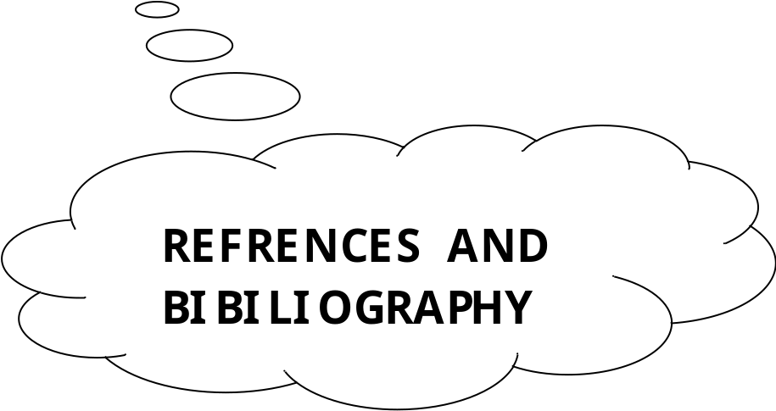

REFERENCES

- http://www.sun.com

- http://www.coreservlets.com

- http://www.serverside.com

- http://www.w3schools.com

- http://www.google.com

- http://www.webopedia.com

- http://www.ddj.com

BIBILIOGRAPHY

BOOKS

- J2EE by GARRY CORNELL.

- J2EE by Allamaraju & Buest (Apress Publications).

- JSP & Servlets by Marty Hall (SUN Microsystems)

- SYSTEM ANALYSIS AND DESIGN by ELIAS M AWAD.

- SOFTWARE ENGINEERING by IAN SOMMEVILLE.

- GNIX INFO SOFT MATERIALS

